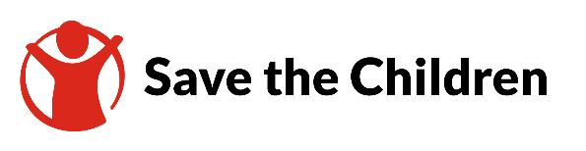

TENDER NOTICE

Date of First Publication: 15 October 2023

Save the Children believes every child deserves a future. In Nepal and around the world, we give children a healthy start in life, the opportunity to learn and protection from harm. We do whatever it takes for children – every day and in times of crisis – transforming their lives and future we share. Save the Children expects that anyone associated with it abides by its Safeguarding and other Zero Tolerance Policies.

Save the Children, Nepal Country Office is inviting submissions of tenders for NON-FOOD ITEMS (NFIs) from qualified service providers.

Detailed instructions and tender response documents are available from 15 October 2023 upon request at “nepal.tenders@savethechildren.org”. When emailing your request, you must provide tender reference number (SCI-NEP-ITT-CO-2023—005, NFI items), your company name, your name, contact number, other valid email address, with scanned copy of company registration, VAT registration, and tax clearance certificate of FY 2078/079

Last day to submit bid: Tuesday, 21 November 2023, 16:00 HRS Nepal Time

All the submissions need to be in sealed envelope or sent via email at suggested email ID in tender bid document. Details are in the tender response documents.

Save the Children reserves the right to award none, partial, or the entire bids to one, or more bidders.

