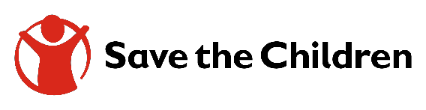
Tender Notice

Date: 17th July, 2023

Invitation to tender for construction of auxiliary infrastructures of 2 Boreholes in Cambarsare village of Gardo District and Baqbaq of Dangorayo District and rehabilitation of 1 Borehole in Kobdhexaad village of Ufeyn district

For over 120 years, Save the Children has been making a difference in children's lives in more than 120 countries. We are the world's largest independent child rights organization, underpinned by a vision in a world in which every child attains the right to survival, protection, development and participation. Our mission to inspire breakthroughs in the way the world treats children, and to achieve immediate and lasting change in their lives.

Save the Children international now invites sealed bids from eligible suppliers for the construction of auxiliary infrastructures of 2 Boreholes in Cambarsare village of Gardo District and Baqbaq of Dangorayo District and rehabilitation of 1 Borehole in Kobdhexaad village of Ufeyn district

The reference of tender is WS1576473828 and complete set of bidding documents can be obtained and downloaded from the link in below.

Download bid Documents here.

- All eligible and interested Bidder/s are requested to download the bidding documents from the above link
- Interested bidders must fill out online bid request form in order to access tender documents on the above link
- Complete bid documents in PDF format can be submitted to The Procurement Committee at Save the Children, Garowe Office
- Bids can also be submitted online in accordance with guidance provided in the ITT Part 1 section 6.2 the Submission Format & Bidder Response Document
- Should you need any clarifications, please address your request to puntland.supplychain@savethechildren.org

The deadline for submission of bids is 6th Sep, 2023, at 3.00 PM, East Africa.

NB: Canvassing will lead to automatic disqualification.

Late bids shall be rejected and no liability will be accepted for loss/protected files, late delivery or non-delivery, whatsoever.

