Date: 29-June-2022
ITT Ref: ITT- AFG-KBL-2022-003-Safe Drinking Water Trucking (Supply and Distribution) for Faryab, Sari Pul and Jawzjan Provinces
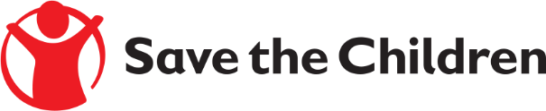
Tender Notice
Save the Children believes every child deserves a future. In Afghanistan and around the world, we give children a healthy start in life, the opportunity to learn and protection from harm. We do whatever it takes for children – every day and in times of crisis – transforming their lives and the future we share.

Save the Children International in Afghanistan is inviting submissions of tenders for Safe Drinking Water Trucking (Supply and Distribution) for Faryab, Sari Pul and Jawzjan Provinces as following:
No. | SPECIFICATION of Goods / Services
1 | Safe Drinking Water Trucking (Supply and Distribution of Safe Drinking Water) for Faryab province different locations
2 | Safe Drinking Water Trucking (Supply and Distribution of Safe Drinking Water) for Sari Pul province different locations
3 | Safe Drinking Water Trucking (Supply and Distribution of Safe Drinking Water) for Jawzjan province different locations

Detailed technical specifications are included within the tender documents.
If you are interested in submitting a bid, please contact Afghanistan Supply chain Department at the following address AFG.Tenders@savethechildren.org to express your interest and request the tender documents. Tender documents will be sent to you by return.
It is recommended to request / collect the tender documents from the date of tender announcement to 7 July 2022.
Completed tender documents are due to be submitted by 13 July 2022 before 3:00 PM Afghanistan time
Please mention in the subject line the Tender Reference # as ITT- AFG-KBL-2022-003-Safe Drinking Water Trucking (Supply and Distribution) for Faryab, Sari Pul and Jawzjan Provinces and tender document will not be accepted after the closing date Wednesday 13 July 2022 after Eid Holidays.

