Version 1.0 /110621

INVITATION TO TENDER
Save the Children International-Afghanistan
29/06/2022
ITT Ref No: ITT-AFG-KBL-2022-003
Provision of Safe Drinking Water Trucking (Supply and Distribution of Safe Drinking Water) for Faryab, Sari Pul and Jawzjan Provinces

SUBMISSION DEADLINE: 08:00am to 03:00PM ON 10/07/2022

PRE-SUBMISSION CLARIFICATION MEETING:

QUESTIONS / CLARIFICATIONS: AFG.Tenders@savethechildren.org

FORMAT FOR SUBMISSION: BIDDER RESPONSE DOCUMENT

PART 1 : INVITATION TO TENDER
  - Introduction to SCI
  - Project Overview and Requirements
  - Award Criteria
  - Instructions & Key Information

PART 2 : CORE REQUIREMENTS AND SPECIFICATION
Detailed description of SCI’s specific requirements (e.g. volumes, delivery dates / locations, product specifications etc).

PART 3 : BIDDER RESPONSE DOCUMENT
Template to be used to submit response to this Invitation to Tender.

PART 1 – INVITATION TO TENDER

INTRODUCTION TO SAVE THE CHILDREN

SCI is the world’s leading independent organisation for children. We save children’s lives; we fight for their rights; we help them fulfil their potential. We work together, with our partners, to inspire breakthroughs in the way the world treats children and to achieve immediate and lasting change in their lives.

Our Vision – a world in which every child attains the right to survival, protection, development and participation.

Our Mission – to inspire breakthroughs in the way the world treats children and to achieve immediate and lasting change in their lives.

We do this through a range of initiatives and programmes, to:

- Provide lifesaving supplies & emotional support for children caught up in disasters (e.g. floods, famine & wars).
- Campaign for long term change to improve children’s lives.
- Improve children’s access to the food and healthcare they need to survive.
- Secure a good quality education for the children who need it most.
- Protect the world’s most vulnerable children, including those separated from their families because of war, natural disasters, extreme poverty or exploitation.
- Work with families to help them out of the poverty cycle so they can feed and support their children.

For more information on the work we undertake and recent achievements, visit our website.

PROJECT OVERVIEW

Item | Description
Description of Goods / Services | Provision of Safe Drinking Water (Supply and Distribution of Safe Drinking Water) for the bellow provinces  - Faryab Province: Daily Need Maximum 250,000 Litter for different location of Faryab Province, fully specified in the Scope for Work for Faryab  - Sari Pul Province: Daily Need Maximum 250,000 Litter for different location of Sari Pul Province, fully specified in the Scope for Work for Sari Pul  - Jawzjan Province: Daily Need Maximum 250,000 Litter for different location of Jawzjan Province, fully specified in the Scope for Work for Jawzjan
Outcome of Tender | Contract – the successful supplier(s) will be awarded a ‘Contract’ for specified goods / services as defined in the Contract at the agreed rates.
Duration of Award | 90 Days Effective from signature of the Contract by parties

Further detail on the specific requirements of the project (e.g. volumes, dates, specifications etc.) can be found in Part 2 (Core Requirements & Specifications) of this Tender Pack.

AWARD CRITERA

SCI is committed to running a fair and transparent tender process, and ensuring that all bidders are treated and assessed equally during this tender process. Bidder responses will be evaluated against four weighted categories of criteria: Essential Criteria, Sustainability Criteria, Capability Criteria, and Commercial Criteria.

ESSENTIAL CRITERIA
Criteria which bidders must meet in order to progress to the next round of evaluation. If a bidder does not meet any of the Essential Criteria, they will be excluded from the tender process immediately. These criteria are scored as ‘Pass’ / ‘Fail’.

3.2 SUSTAINABILITY CRITERIA (10%)
Criteria used to evaluate the impact a supplier has on the environment, local economy and community. Bids will be evaluated against the same pre-agreed Criteria.

3.3 CAPABILITY CRITERIA (49%)
Criteria used to evaluate the bidder’s ability, skill and experience in relation to the requirements. Bids will be evaluated against the same pre-agreed Criteria.

3.4 COMMERIAL CRITERIA (41%)
Criteria used to evaluate the commercial competitiveness of a bid. Bids will be evaluated against the same pre-agreed Criteria.

VETTING

Successful bidders must be successfully vetted. This involves checking bidders and key personnel against Global Watch Lists, Enhanced Due Diligence Lists and Politically Exposed Persons Lists.

The vetting of bidders will be completed after the award decision and prior to any contract being signed, or orders placed. If any information provided by the Bidder throughout the tender process is proved to be incorrect during the vetting process (or at any other point), SCI may withdraw their award decision.

BIDDER INSTRUCTIONS

6.1 TIMESCALES

Activity | Date
Issue Invitation to Tender | 29 June 2022
Deadline for questions from Bidders | 07 July 2022
Deadline for Bid Submission | 13 July 2022
Bid Clarifications | 23 July 2022
Award Contact | 04 Aug 2022

The above dates are for indicative purposes only and are subject to change.

6.2 SUBMISSION FORMAT & BIDDER RESPONSE DOCUMENT
Bidders wishing to submit a bid must use the Bidder Response Document template in Part 3 of this Tender Pack. Any bids received using different formats, or incomplete bids, will not be accepted.

This document allows bidders to submit all the required information and be evaluated fairly and equally against the Essential, Capability and Commercial Criteria. Bidders may also be required to submit supporting documentation. Further instructions can be found within the document in Part 3 of this pack.

Bids can be submitted by:
Paper Submission
- Bids should be submitted in a single sealed envelope addressed to Save the Children International – Afghanistan Country Office, Street 5, Qalai Fatullah, Kabul Afghanistan.
- The envelope should clearly indicate the Invitation to tender reference number ITT-AFG-KBL-2022-003 Safe Drinking Water Trucking to Faryab, Sari Pul and Jawzjan Provinces but contain no other details relating to the bid or the bidder’s name.
- All supporting documentation should be labelled and grouped together (individual envelopes, stapled etc), and then included in a single sealed envelope as per the above.

6.4 CLOSING DATE FOR BID SUBMISSION
Your bid must be received, no later than Wednesday 13/07/2022 after Eid Holidays.

Bids must remain valid for 6 Months and open for consideration for a period of no less than 90 days.

6.5 KEY CONTACTS
All questions relating to the tender should be sent via email to:

Name | Email Address
Save The Children -AF, Supply Chain Department | AFG.Tenders@savethechildren.org

Please be advised local working hours are 8:00am – 4:00pm and official Working days are Sunday to Thursday. Tender packages are shared within Two working days from bidder request. If you did not receive it, please follow up using the same email address.

Where the enquiry may have an impact on other bidders within the process, Save the Children will notify all other Bidders to maintain a fair and transparent process.

PART 2 – CORE REQUIREMENTS & SPECIFICATIONS

- SPECIFIC REQUIREMENTS
Provision of Safe Drinking Water Trucking, for Faryab, Sari Pul and Jawzjan Provinces as fully described in the bellow tables and in Section 3 (Commercial Questions) of Part 3 - Bidder response

- SPECIFICATIONS

Provision and Distribution of Safe Drinking water via Water Trucking in Faryab Province

Save the Children Afghanistan is planning to provide and distribute the safe and drinking water via water trucking to vulnerable families in the targeted villages and districts of Faryab Province as per below Scope of work:

Scope of Work:
- Delivery of safe drinking water via water trucking in Faryab province,
- Distribution of safe drinking water via water trucking in targeted villages and districts,
- The tanker and driver should be accessible to the targeted villages.
- The tanker should be only used for drinking water purposes,
- The contractor should use the specified water sources for filling the water tankers,
- Contractor is responsible to take safe water from sources, fill the tankers, deliver the safe water to targeted villages and distribute the safe drinking water in the villages.
- The water will be tested by Save the Children International (SCI) team in the field using Water Quality test equipment such as pH Meter, TDS meter, Turbidity upgrade, Pool tester for testing Drinking Water, Media H2S (Coliform & E. Coli) and others,
- If the water quality is not matching with the WHO standards (PH should be between 6.5 to 8, TDS under 1000, E-coli = 0, turbidity under 5NTU), then the contractor is responsible for chlorination of water in the tanker according to SCI water chlorination guideline,
- Daily water demand for targeted district and villages in Faryab province is 250,000 Liters, if there is a tanker with 10,000 Liters capacity, then daily base 25 tankers should be used to meet the demand (Number of Water Tanker depend on capacity of each tanker which should meet Daily 250,000 Liters water demand),
- The tanker should have required pipes to distribute the water to consumers,
- Water truck will have multiple stays during water distribution.
- The Water Trucking duration will be 90 days with the Coordination of SCI provincial team,
- Daily Targeted beneficiaries [250,000 Liters / (15 lpcd+1 liter extra) = 15625 consumer beneficiaries], and [15625 consumers /7 member of each family = 2232 households]
- The tanker driver should complete the required documentation and signing for delivery of each tanker.

Below table shows the water trucking details in Faryab Province:

No | Targeted district | targeted village | No of HH | Distance from resource | Water demand Liter | Distribution points |  | Source of water for trucks | No of trucks needed with 10,000 Liters
1 | Qurghan | Kohna Qorghan | 380 | 10.7km | 40,000 | N36*55'31.4" | E065*03'44.5" | Market | 4 Trucks
 |  |  |  |  |  | N36*55'31.6" | E065*03'29.7"
 |  |  |  |  |  | N36*55'32.8" | E065*03'46.6"
 |  | Yaka Pata | 180 | 10.2 km | 20,000 | N36*59'44.5" | E065*03'13.8" | Market | 2 trucks
2 | Qaramqol | Central Qaramqul | 170 | 16.1km | 20,000 | 36°51'33.4"N | 65°03'30.3"E | Market | 2 trucks
 |  |  |  |  |  | 36°51'50.5"N | 65°03'50.8"E
 |  | Qazi Kent | 180 | 19 km | 20000 | 36°51'02.4"N | 65°07'23.6.8"E | Market | 2 trucks
 |  |  |  |  |  | 36°51'05.5"N | 65°07'32.9"E
3 | Andkhoy | Dahyakchi khana | 170 | 10.1 km | 20,000 | 36°54'47.9"N | 65°06'27.8"E | Market | 2 trucks
 |  | Sabad froshan | 85 | 11.3 km | 10,000 | N36*54'29.9" | E065*06'09.7" | Market | 1 truck
 |  | Yangi tegerman | 80 | 12.4 | 10,000 | N36*54'36.3" | E065*06'48.1" | Market | 1 truck
 |  | Jar tegerman | 165 | 12.9 | 20,000 | N36*54'01.6" | E065*05'48.2" | Market | 2 trucks
4 | Khan Charbagh | Chakman Payeen | 175 | 11 km | 20,000 | N36*57'18.7" | E065*12'43.5" | Market | 2 trucks
 |  |  |  |  |  | N36*57'07.4" | E065*13'09.7"
 |  | Chakman Bala | 81 | 7.1 km | 10,000 | 36°57'17.0"N | 65°10'51.7"E | Market | 1 truck
 |  | Kohna Qala | 177 | 5 km | 20,000 | 36°58'54.7"N | 65°08'48.8"E | Market | 2 trucks
 |  |  |  |  |  | 36°59'13.9"N | 65°09'12.8"E
5 | Qaisar | Sofi Qala | 180 | 62 km | 20000 Lit | N35*42'13.8" | E064*14'31.8" | Market | 2 trucks
 |  |  |  |  |  | N35*42'11.2" | E064*14'37.4"
 |  |  |  |  |  | N35*42'11.2" | E064*14'37.4"
6 | Khawja sabzpush | Aq Mazar | 80 | 50 km | 10,000 | 36°02'27.7"N | 65°02'34.9"E | Market | 1 truck
 |  | Murcha ghal | 80 | 58 km | 10,000 | 36°01'53.2"N | 65°01'12.7"E | Market | 1 truck

Qurghan district

Source of water for trucks: Andkhoy market (36°56'33.5"N 65°09'33.7"E)
Route map: Kohna Qorghan
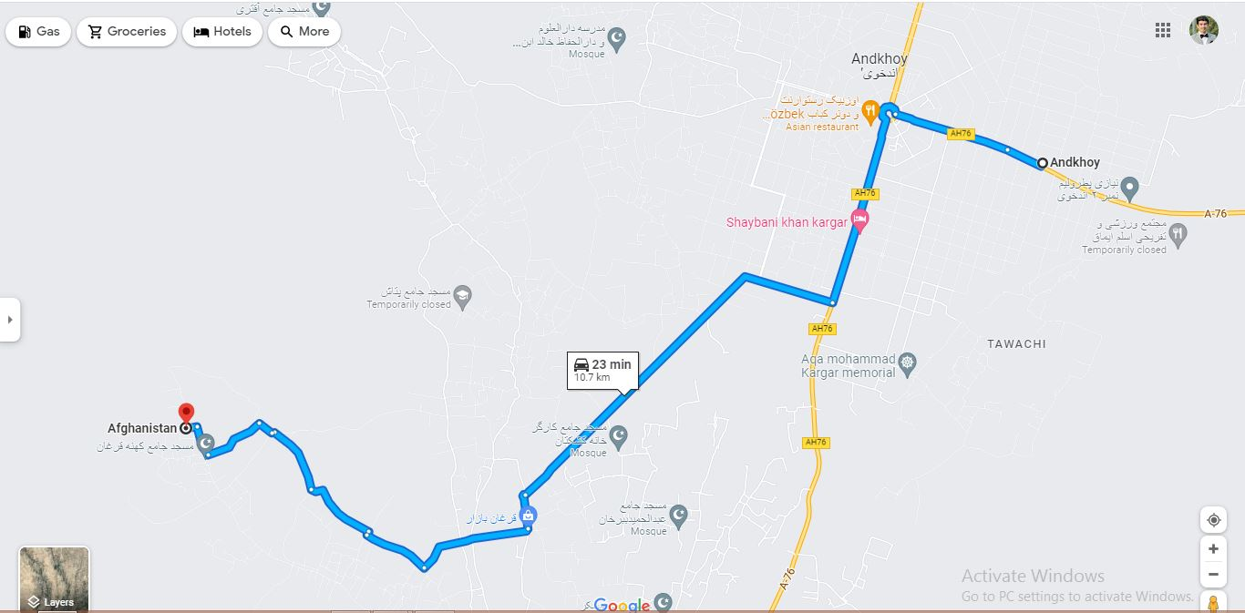
Route map: Yaka pata
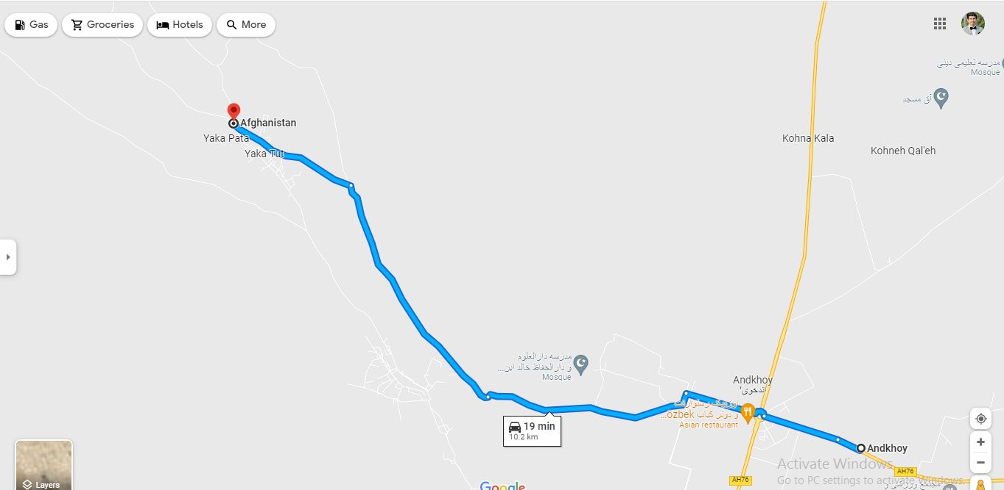
Qaramqul district

Source of water for trucks: Andkhoy market (36°56'33.5"N 65°09'33.7"E)
Route map: Central Qaramqul
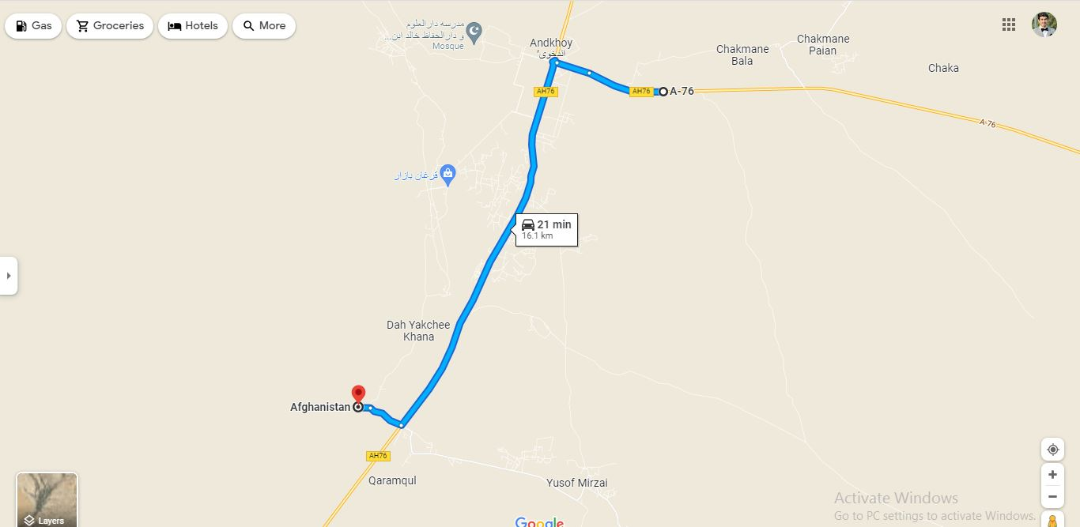
Route map: Qazi kent
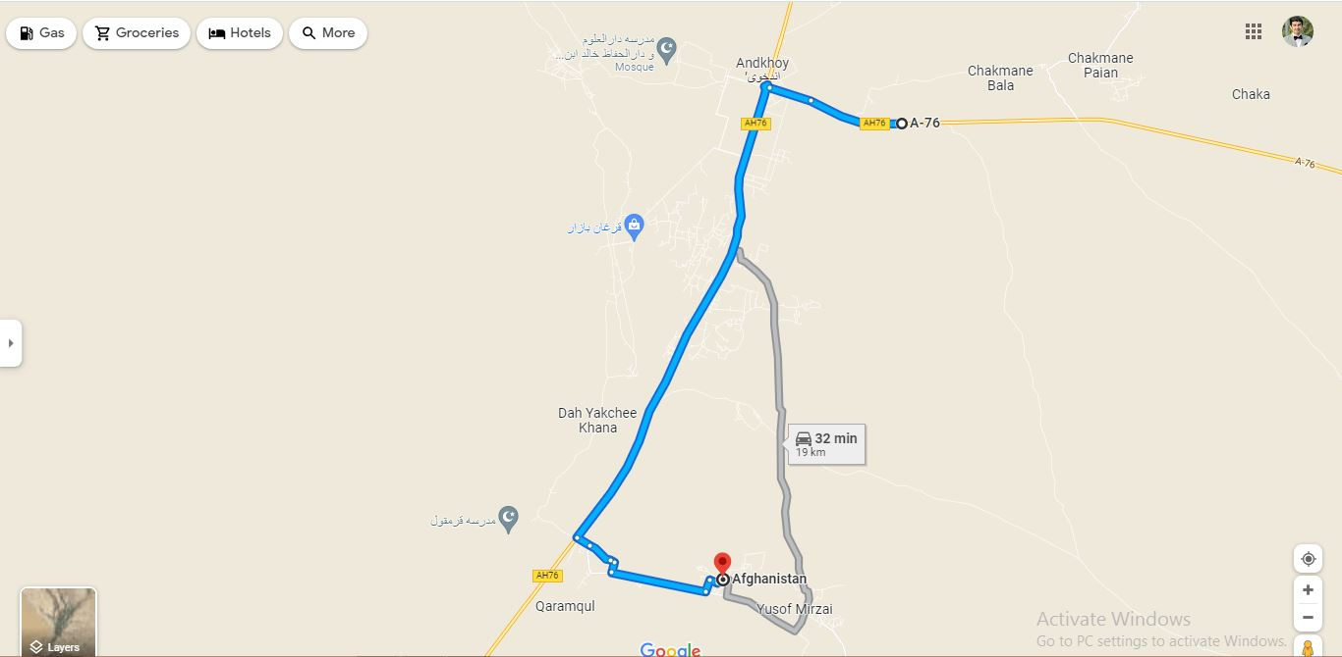

Andkhoy district

Source of water for trucks: Andkhoy market (36°56'33.5"N 65°09'33.7"E)
Route map: Dehyakchi khana
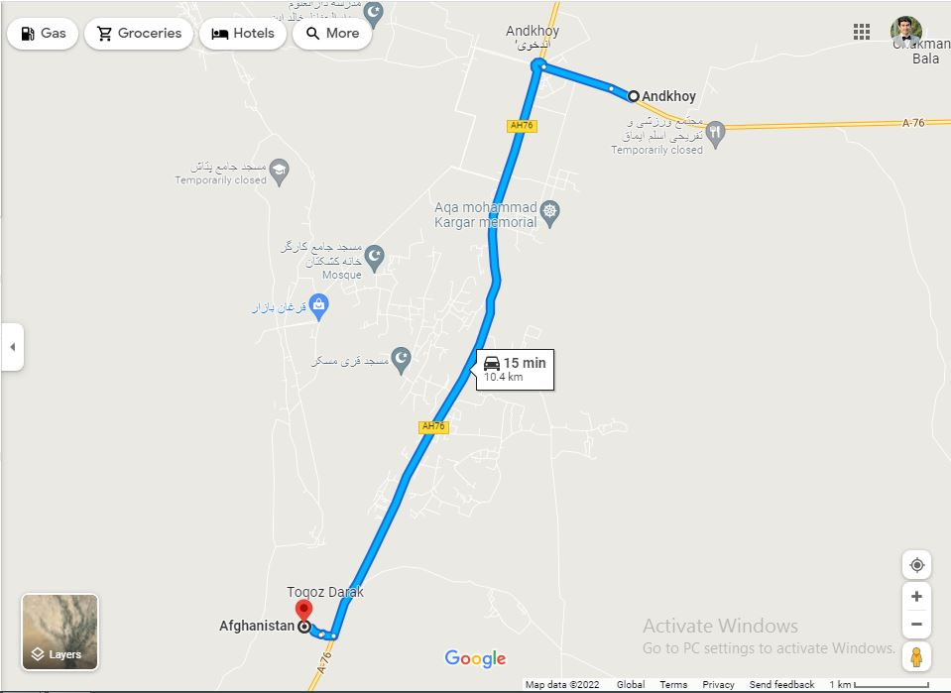
Route map: Sabad froshan
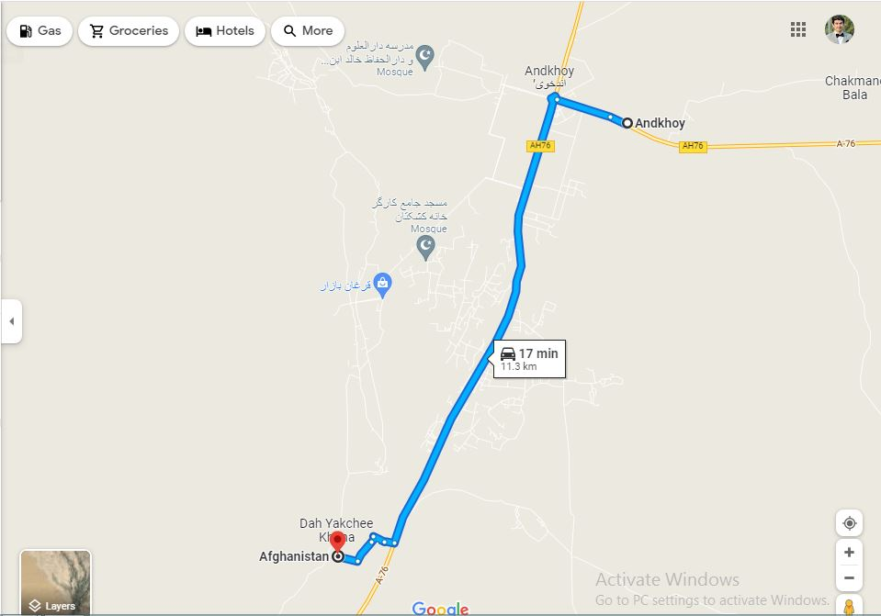

Route map: Jar tegerman
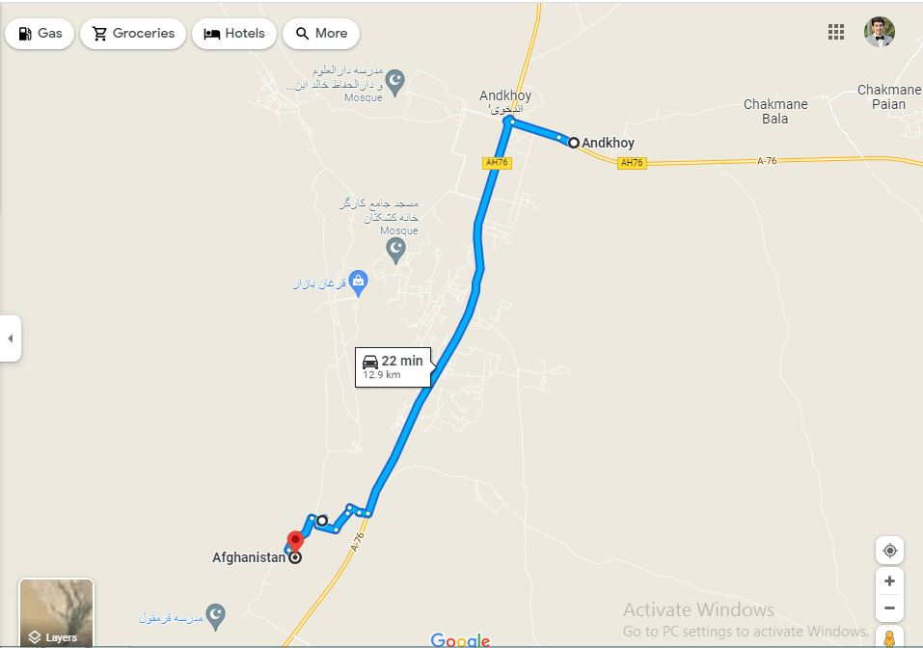
Route map: Yangi tegerman
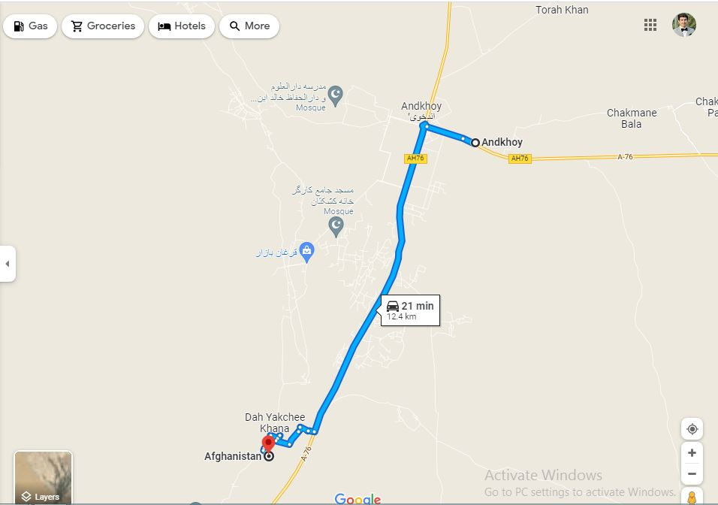

Khancharbagh district

Source of water for trucks: Andkhoy market (36°56'41.7"N 65°09'31.7"E)
Route map: Chakman Payeen
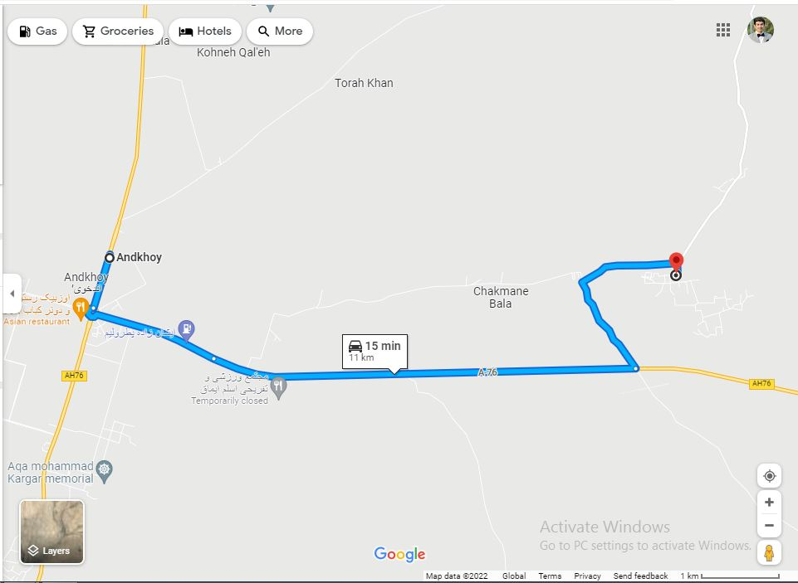
Route map: Chakman bala
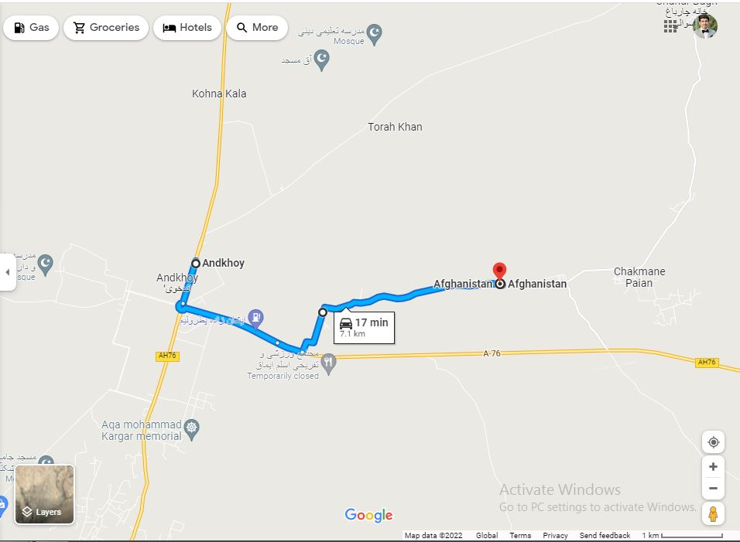
Route map: Kohna Qala
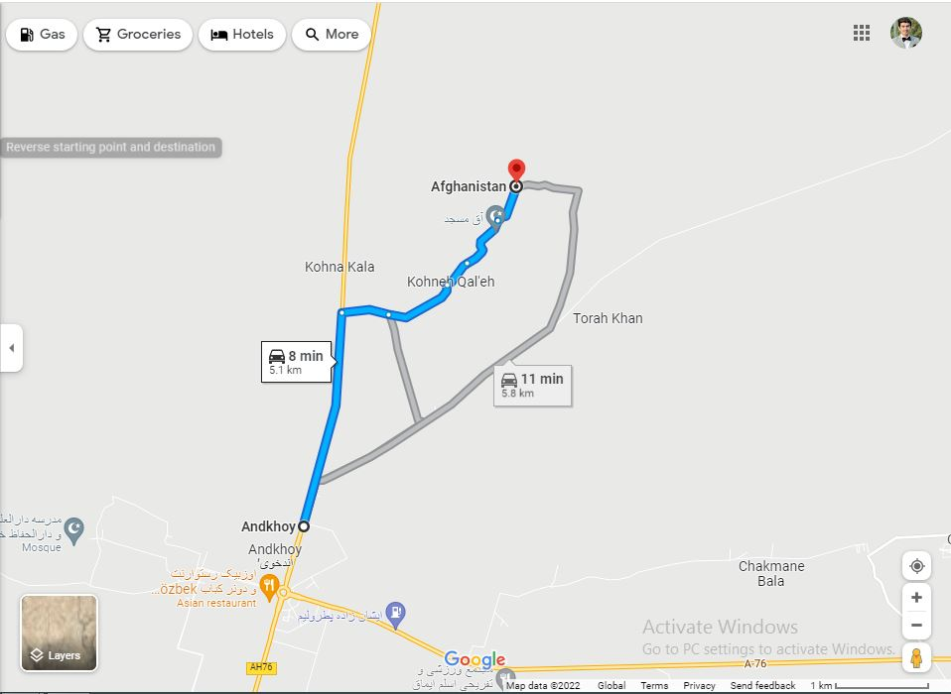

Qaisar district
Source of water for trucks: Maimana market (35°55'23.3"N 64°47'34.7"E)
Route map
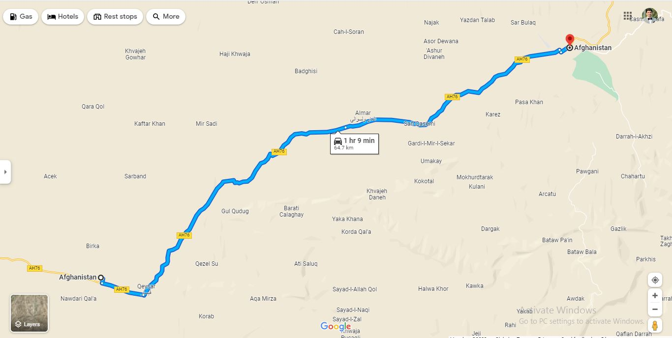

Khawja Sabzposh district

Source of water for trucks: Maimana market (35°55'23.3"N 64°47'34.7"E)
No direct route map is available for Aqdara and Morchaghal.
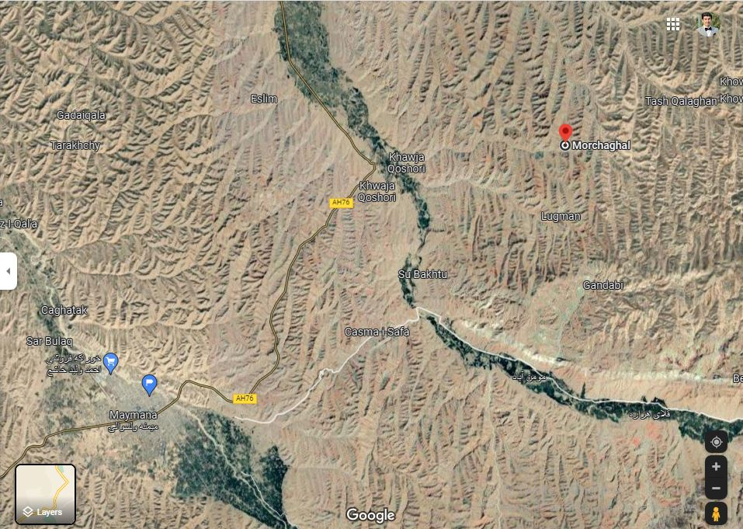

Provision and Distribution of Safe Drinking water via Water Trucking in Sar-e-Pul Province

Save the Children Afghanistan is planning to provide and distribute the safe and drinking water via water trucking to vulnerable families in the targeted villages and districts of Sar-e-Pul Province as per below Scope of work:

Scope of Work:
- Delivery of safe drinking water via water trucking in Sar-e-Pul province,
- Distribution of safe drinking water via water trucking in targeted villages and districts,
- The tanker and driver should be accessible to the targeted villages.
- The tanker should be only used for drinking water purposes,
- The contractor should use the specified water sources for filling the water tankers,
- Contractor is responsible to take safe water from sources, fill the tankers, deliver the safe water to targeted villages and distribute the safe drinking water in the villages.
- The water will be tested by Save the Children International (SCI) team in the field using Water Quality test equipment such as pH Meter, TDS meter, Turbidity upgrade, Pool tester for testing Drinking Water, Media H2S (Coliform & E. Coli) and others,
- If the water quality is not matching with the WHO standards (PH should be between 6.5 to 8, TDS under 1000, E-coli = 0, turbidity under 5NTU), then the contractor is responsible for chlorination of water in the tanker according to SCI water chlorination guideline,
- Daily water demand for targeted district and villages in Sar-e-Pul province is 250,000 Liters, if there is a tanker with 10,000 Liters capacity, then daily base 25 tankers should be used to meet the demand (Number of Water Tanker depend on capacity of each tanker which should meet Daily 250,000 Liters water demand),
- The tanker should have required pipes to distribute the water to consumers,
- Water truck will have multiple stays during water distribution.
- The Water Trucking duration will be 90 days with the Coordination of SCI provincial team,
- Daily Targeted beneficiaries [250,000 Liters / (15 lpcd+1 liter extra) = 15625 consumer beneficiaries], and [15625 consumers /7 member of each family = 2232 households]
- The tanker driver should complete the required documentation and signing for delivery of each tanker.

Below description and table shows the water trucking details in Sar-e-Pul Province:

Water Tanker to distribute safe water by Tanker in Sar-e-Pol center, (Sayad, SozmaQala, Sancharak & Gosfandi districts)
The locations and Requires safe water as per litter per day:
- Center of Sar-e-Pol:
- Sheram& Naymadan (Qari Fazluddin, Naw Haji, Mahkam Say, Sar Shor villages- Require (20,000 litter) water per day, *Majar Mohammad Ismail, Majar Abdul Salam, Kalta Bil Shekhan Zay, Ashor bay and Qameshli villages- Require (20,000 litter) water per day. *Alaskar, Sofa Cha & Qodoq Cha) Villages - Require (10,000 ) litter water per day.
- Sayad District:
- Torkchin village - Require (10,000 litter) water per day, *Beland Ghor Afgania- Require (10,000 litter) water per day, *(Kotrama CDC),Quroq Say- Awal Bay- Require (10,000 litter) water per day, * Bazar Kami, Qadoqa villages- Require (10,000 Litter) water per day.
- Sozma Qala Distrcit:
- *Sabzi Kalan, Bagh Ishaq, German Qala villages-Require (40,000 litter) water per day.
- Sacharak District:
- Arab Ulya and Sofla (Sar sarak Arab Bayi, Arab bayi Jamali, Arab bayi Ulya and Arab Bayi Sofla) Villages- Require (40,000 litter) water per day.

- Gosfandi District:
- Kariz Ha (Kosa hayi Kariz, Mahmod Abad, Sayaq, Bay Sarkanda, Masjid Sorkh, Masjid Mohammad Ayob, Masjid Ghajor, Masjid Bangi, Shah Baqi, Zanbor Khana and Majid Abdul Jabar) villages- Require (50,000 litter) Water per day , *Choghdan ha (Choghdan Ulya, Choghdan Sofla & Alaghan) & Shekyar (Yatim Qushlaq, Qoshlaq Kalan, Shekyar Miyana) villages- Require (30,000 litter) water per day.

No. | District | Villages Name | #Villages | Probability Population (Family) | Geological and Hydrogeological Situation | Emergency Statues | Water Resources for water trucking | Distance from water resource with Water truck (km) | Need water by Tanker per day (litter)
1 | Sayad | Torkchin | 1 | 1100 | Mountain and hill zone with subterranean water in depth of (80-100)m. | water trucking and Chlorination | Private Deep wells from the center of Sar-e-Pol | 30 km | 10,000
 |  | Beland Ghor Afghania | 1 | 900 | Mountain and hill zone with subterranean freshwater | water trucking and Chlorination | Private Deep wells from the center of Sar-e-Pol | 30 km | 10,000
 |  | Quroq Say, Awal bay (Kotarma CDC) | 2 | 1100 | Mountain and hill zone with subterranean water in depth of (80-100)m salt water | water trucking and Chlorination | Private Deep wells from the center of Sar-e-Pol | 40 km | 10,000
 |  | Bazar Kami, Qodoqa | 2 | 1300 | Desert and hill area with subterranean less fresh water | water trucking and Chlorination | Private Deep wells from the center of Sar-e-Pol | 55 km | 10,000
2 | Sozma Qala | Sabzi Kalan, Bagh Ishaq, German Qala | 3 | 3800 | Desert and hill area with subterranean less fresh water | water trucking and Chlorination | Private Deep wells from the center of SozmaQala | 35 km | `40,000
3 | Sancharak | Arab Ulya and Sofla (Sar sarak Arab Bayi, Arab bayi Jamali, Arab bayi Ulya and Arab Bayi Sofla) | 4 | 2800 | Desert and hill area with subterranean less fresh water | water trucking and Chlorination | Private deep wells | 30 km | 40,000
4 | Gosfandi | Kariz Ha (Kosa hayi Kariz, Mahmod Abad, Sayaq, Bay Sarkanda, Masjid Sorkh, Masjid Mohammad Ayob, Masjid Ghajor, Masjid Bangi, Shah Baqi, Zanbor Khana and Majid Abdul Jabar) | 11 | 4200 | Mountain and hill zone with subterranean Salt Water | water trucking and Chlorination | Private Deep wells from the center of Gosfandi | 35 km | 50,000
 |  | Choghdan ha (Choghdan Ulya, Choghdan Sofla & Alaghan) & Shekyar (Yatim Qushlaq, Qoshlaq Kalan, Shekyar Miyana) | 6 | 1800 | Mountain and hill zone with subterranean Salt Water | water trucking and Chlorination | Private Deep wells from the center of Gosfandi | 40 km | 30,000
5 | Center | Sheram& Naymadan (Qari Fazluddin, Naw Haji, Majar Mohammad Ismail, Majar Abdul Salam, Say Haji, Qameshli, Kalta Bil, Shekhan Zay, Alaskar, Mahkam Say, Sar Shor, Sofa Cha & Qodoq Cha) | 13 | 5600 | Mountain and hill zone with subterranean Salt Water | water trucking and Chlorination | Private Deep wells from the center of Sar-e-Pol | 50 km | 50,000

Provision and Distribution of Safe Drinking water via Water Trucking in Jawzjan Province

Save the Children Afghanistan is planning to provide and distribute the safe and drinking water via water trucking to vulnerable families in the targeted villages and districts of Jawzjan Province as per below Scope of work:

Scope of Work:
- Delivery of safe drinking water via water trucking in Jawzjan province,
- Distribution of safe drinking water via water trucking in targeted villages and districts,
- The tanker and driver should be accessible to the targeted villages.
- The tanker should be only used for drinking water purposes,
- The contractor should use the specified water sources for filling the water tankers,
- Contractor is responsible to take safe water from sources, fill the tankers, deliver the safe water to targeted villages and distribute the safe drinking water in the villages.
- The water will be tested by Save the Children International (SCI) team in the field using Water Quality test equipment such as pH Meter, TDS meter, Turbidity upgrade, Pool tester for testing Drinking Water, Media H2S (Coliform & E. Coli) and others,
- If the water quality is not matching with the WHO standards (PH should be between 6.5 to 8, TDS under 1000, E-coli = 0, turbidity under 5NTU), then the contractor is responsible for chlorination of water in the tanker according to SCI water chlorination guideline,
- Daily water demand for targeted district and villages in Jawzjan province is 250,000 Liters, if there is a tanker with 10,000 Liters capacity, then daily base 25 tankers should be used to meet the demand (Number of Water Tanker depend on capacity of each tanker which should meet Daily 250,000 Liters water demand),
- The tanker should have required pipes to distribute the water to consumers,
- Water truck will have multiple stays during water distribution.
- The Water Trucking duration will be 90 days with the Coordination of SCI provincial team,
- Daily Targeted beneficiaries [250,000 Liters / (15 lpcd+1 liter extra) = 15625 consumer beneficiaries], and [15625 consumers /7 member of each family = 2232 households]
- The tanker driver should complete the required documentation and signing for delivery of each tanker.

Below table shows the water trucking details in Jawzjan Province:

District | Villages Name | #Villages/ CDCs | Probability Population (Family) | Geological and Hydrogeological Situation | Emergency Statues | Water Resources for water trucking and chlorination | Distance from water resource with Water truck (km) | Need water by Tanker per day (litter)
Khoja Dokoh | Ramat Abad and Haqabad | 2 | 1540 | Silt and clay hill zone with underground water in this area are not drinkable due to high contamination of oils and minerals as it is located in oil stoning location | water trucking | Municipality Deep wells from the center of Sherbirghan City | 18 Km | 20,000
 | Bashi kot, Katai Sai, Majid Qodoq, Yaka Sai | 4 | 4200 | Silt and clay hill zone with underground water in this area are not drinkable due to high contamination of oils and minerals as it is located in oil stoning location | water trucking | Municipality Deep wells from the center of Sherbirghan City | 58 km | 60,000
Shebirghan | Cheghchee, Chobash Bala, Chobash Payen, Bakawol, Delaram, Shoraregh bala, Shoraregh Payen, Shoraregh turkmania, Taghan Aregh Afghania, Taghan Aregh Turkmania, Eraghlee, Oramast, Mesrabad bala, mesrabad payen, mesrabad Wasat, Islam Joy, Charshanba, Nekrabad, Qomsai,Qanjogha Bala, Qanjogha Payen, Khatoon Qala,Bayenghor | 23 | 15000 | These villages are located in east of Shebirghan city, unfortunately the underground water in these areas are not to too tasty and drinkable, due to high contamination of chemical and minerals | Water Trucking | Municipality Deep wells from the center of Sherbirghan City | 8-30 KM | 170,000

- ADDITIONAL INFORMATION
The full specification and quantity of the goods are clearly described in Section 3 -Commercial Question.
SCI has the right to award a contract for Three provinces, two Provinces, or one Province to each potential supplier for provision and distribution of Safe drinking Water to Faryab, Sari Pul and Jawzjan Provinces in different locations / villages of different districts of each province.
Note: Please read the Scope of Work for each province clearly and then provide your quotation in Section 3 Commercial part.

PART 3 – BIDDER RESPONSE DOCUMENT

- INTRODUCTION
This document MUST BE USED by Bidders wishing to submit a bid. It is linked into 5 sections detailed below:
- Section 1 – Essential Criteria
- Section 2 – Capability & Sustainability Questions
- Section 3 – Commercial Questions
- Section 4 – Bidder Submission Checklist
The Bidder is required to sign a copy of the Check list in Section 4 as part of their submission.

- INSTRUCTIONS
Within each section there are instructions providing guidance to the bidder on what information is required. This guidance details the MINIMUM requirements expected by SCI. If a Bidder wishes to add further information, this is acceptable, but the additional information should be limited to only items that are relevant to the tender.
- For the avoidance of doubt, bidders are required to complete all items within the Bidder Response Document unless clear instruction is provided otherwise.
- If a Bidder does not complete the entire Bidder Response document, their submission may be declared void.
- If a Bidder is unable to complete any element of the Bidder Response Document, they should contact Save the Children using the contact details provided for guidance.
By submitting a response, the bidder confirms that all information provided can be relied upon for validity and accuracy.

SECTION 1 - ESSENTIAL CRITERIA
INSTRUCTIONS – Bidders are required to complete all sections of the below table.
Item | Question | Bidder Response
1 | Supplier accepts Save the Children’s ‘Terms and Conditions of Purchase’ included within Appendix 1 of the ITT, and that any work awarded from this tender process will be completed under the attached ‘Terms and Conditions of Purchase’ | Yes / No | Comments / Attachments
2 | The Supplier and its staff (and any sub-contractors used) agree to comply with SCI and the IAPG’s policies and code of conducts listed below.  1) Child Safeguarding Policy  2) Anti-Bribery & Corruption Policy  3) Human Trafficking & Modern Slavery Policy  4) Protection from Sexual Exploitation and Abuse Policy  5) Anti-Harassment, Intimidation & Bullying Policy  6) IAPG Code of Conduct  7) Conditions of Tendering | Yes / No | Comments
3 | The Supplier confirms it is not linked directly or indirectly to any terrorism related activity. | Yes / No | Comments
4 | The bidder confirms they are not a prohibited party under applicable sanctions laws or anti-terrorism laws or provide goods under sanction by the United States of America or the European Union and accepts that SCI will undertake independent checks to validate this. | Yes / No | Comments
5 | Supplier accepts that all custom-related and domestic taxes clearances and issues are their responsibility | Yes / No | Comments
6 | Supplier accepts the Delivery and Distribution to the locations in specific province they are bidding to. | Yes / No | Comments
7 | The supplier should provide bank statement to show $ 200,000 or equivalent turnover in any of last 5 years | Yes / No | Comments
8 | The Supplier confirms it is fully qualified, licenses and registered to trade with Save the Children (including compliance with all relevant Afghanistan Country legislation).  This includes the Supplier submitting the following requirements (where applicable):  - Business registration certificate in Afghanistan  - Bank account details by the name of company  - provide tax clearance document no older than 1399. | Yes / No | Comments
 |  | Document | Evidence Attached

SECTION 2 – CAPABILITY & SUSTAINABILITY QUESTIONS
Instructions – Bidders are required to complete all sections of the below table.
Item | Score | Question | Bidder Response
1 | 9 % | Experience  Provision of 3 contracts copies with NGOs, INGOs, and Government with similar scope and scales.  Each Contract will get 3 marks
2 | 10 % | a)- The supplier should provide a confirmation letter that they will provide and distribute safe drinking water via water trucking for all locations.  b)-The supplier should confirm that they will provide heavy duty track and familiar drivers for the locations where the normal tracks cannot move.  5 marks for provision of confirmation letter for each part.  0 Mark for not provision of confirmation letter. | Bidder Response
3 | 10 % | Volume and Lead Times  Volume need: Per day need maximum 250,000 Litters Safe Drinking Water for each province  Every province has different locations  Daily water demand for targeted district and villages in each province is maximum 250,000 Litters, if there is a tanker with 10,000 Litters capacity, then daily base 25 tankers should be used to meet the demand (Number of Water Tanker depend on capacity of each tanker which should meet Daily 250,000 Litters water demand),  Lead time: Daily basis /with consultation of SCI provincial team.  The Vendor must provide a written Confirmation that they are able to provide Safe Drinking Water Tanker for the Selected locations in the provinces they are Bidding to.  Please Tick Mark the province you are bidding to.  - Faryab  - Sari Pul  - Jawzjan  10 Mark for Confirmation for having the capability to provide maximum need 250,000 Litter Safe Drinking Water in a day for different locations in every province, as fully described in the Scope of Work of each province.
5 | 5% | Delivery  The vendor is able to provide written confirmation that they can arrange direct delivery to all Locations selected by SCI for Water Distribution points in the province they are bidding  5 Marks for provision of written confirmation
6 | 5% | Distribution:  The vendor should provide a confirmation letter for multiple staying in the distribution points until the beneficiaries received the required water.
7 | 10% | Bank Statement:  The supplier should provide bank statement for the last five years to show the turnover of consecutive 3 years of $200,000 turnover or equivalent.

SUSTAIBILITY QUESTIONS
Instructions – Bidders are required to complete all sections of the below table.
Item | Evaluation Criteria | Sustainability Criteria Description  (Minimum Weighting is 10%) | Bidder Response Question No
1 | 10 % | The Bidder is registered / has its primary operations in close proximity to the programming location.  10/10 - bidder is registered (or has its primary operations) in the same town / city / community or very close proximity.  5/10 - bidder is registered (or has its primary operations in) the same region / governorate / district.  0/10 - bidder is registered (or has its primary operations) elsewhere.

COMMERIAL CRITERIA (41%)
Criteria used to evaluate the commercial competitiveness of a bid. Bids will be evaluated against the same pre-agreed Criteria.

SECTION 3 – COMMERCIAL QUESTIONS
- Please indicate here the prices including delivery to each locations and taxes you are offering to Save the Children as part of this Contract, please refer to specification for details of what must be included. The price will be in USD and the payment will be in AFN as per the exchange rate from the date Invoice Authorization is prepared.
- Faryab Province: Commercial
Faryab Province Supply and Distribution of Safe Drinking Water via Water Trucking (Tanker) Commercial part
No. | Targeted district | targeted village | No of Household | Distance from resource | Water demand Litre | Distribution points |  | Source of water for trucks | No of trucks needed with 10,000 Litres / day | Unit Price USD | Total Price USD
1 | Qurghan | Kohna Qorghan | 380 | 10.7km | 40,000 | N36*55'31.4" | E065*03'44.5" | Market | 4 Trucks
 |  | Yaka Pata | 180 | 10.2 km | 20,000 | N36*55'31.6" | E065*03'29.7" | Market | 2 trucks
2 | Qaramqol | Central Qaramqul | 170 | 16.1km | 20,000 | N36*55'32.8" | E065*03'46.6" | Market | 2 trucks
 |  | Qazi Kent | 180 | 19 km | 20000 | N36*59'44.5" | E065*03'13.8" | Market | 2 trucks
3 | Andkhoy | Dahyakchi khana | 170 | 10.1 km | 20,000 | 36°51'33.4"N | 65°03'30.3"E | Market | 2 trucks
 |  | Sabad froshan | 85 | 11.3 km | 10,000 | 36°51'50.5"N | 65°03'50.8"E | Market | 1 truck
 |  | Yangi tegerman | 80 | 12.4 km | 10,000 | 36°51'02.4"N | 65°07'23.6.8"E | Market | 1 truck
 |  | Jar tegerman | 165 | 12.9 km | 20,000 | 36°51'05.5"N | 65°07'32.9"E | Market | 2 trucks
4 | Khan Charbagh | Chakman Payeen | 175 | 11 km | 20,000 | 36°54'47.9"N | 65°06'27.8"E | Market | 2 trucks
 |  | Chakman Bala | 81 | 7.1 km | 10,000 | N36*54'29.9" | E065*06'09.7" | Market | 1 truck
 |  | Kohna Qala | 177 | 5 km | 20,000 | N36*54'36.3" | E065*06'48.1" | Market | 2 trucks
5 | Qaisar | Sofi Qala | 180 | 62 km | 20,000 | N36*54'01.6" | E065*05'48.2" | Market | 2 trucks
6 | Khawja sabzpush | Aq Mazar | 80 | 50 km | 10,000 | 36°02'27.7"N | 65°02'34.9"E | Market | 1 truck
 |  | Murcha ghal | 80 | 58 km | 10,000 | 36°01'53.2"N | 65°01'12.7"E | Market | 1 truck
Total Price for 1 day =
Total Price for 90 days = 1day total price x 90 days =

- Sari Pul Province: Commercial
Sari Pul Province Supply and Distribution of Safe Drinking Water via Water Trucking (Tanker) Commercial part
No. | Targeted district | targeted villages | Probability Population (Family) | Distance from Source of Water Wells | Water demand Litre | Distribution points | Source of water for trucks | No of trucks needed with 10,000 Litres / day | Unit Price USD | Total Price USD
1 | Sayad | 1 Village as bellow  Torkchin | 1100 | 30 km | 10,000 | targeted village | Private Deep Wells from the Centre of Sari Pul | 1 Truck
 |  | 1 Village as bellow  Beland Ghor Afghania | 900 | 30 km | 10,000 | targeted village | Private Deep Wells from the Centre of Sari Pul | 1 Truck
 |  | 2 Villages as bellow  Quroq Say, and Awal bay (Kotarma CDC) | 1100 | 40 km | 10,000 | targeted villages | Private Deep Wells from the Centre of Sari Pul | 1 Truck
 |  | 2 Villages as bellow  Bazar Kami and Qodoqa | 1300 | 55 km | 10,000 | targeted villages | Private Deep Wells from the Centre of Sari Pul | 1 Truck
2 | Sozma Qala | 3 Villages as bellow  Sabzi Kalan, Bagh Ishaq, and German Qala | 3800 | 35 km | 40,000 | targeted villages | Private Deep Wells from the Centre of Sozma Qala | 4 Trucks
3 | Sancharak | 4 Villages as bellow  Arab Ulya and Sofla (Sar sarak) Arab Bayi, Arab bayi Jamali, Arab bayi Ulya and Arab Bayi Sofla) | 2800 | 30 km | 40,000 | targeted villages | Private Deep Wells | 4 Trucks
4 | Gosfandi | 11 Villages as bellow Kariz Ha (Kosa hayi Kariz, Mahmod Abad, Sayaq, Bay Sarkanda, Masjid Sorkh, Masjid Mohammad Ayob, Masjid Ghajor, Masjid Bangi, Shah Baqi, Zanbor Khana and Majid Abdul Jabar) | 4200 | 35 km | 50,000 | targeted villages | Private Deep Wells | 5 Trucks
 |  | 6 Villages as bellow  Choghdan ha (Choghdan Ulya, Choghdan Sofla & Alaghan) & Shekyar (Yatim Qushlaq, Qoshlaq Kalan, Shekyar Miyana) | 1800 | 40 km | 30,000 | targeted villages | Private Deep Wells | 3 Trucks
5 | Sari Pul Centre | 13 Villages as bellow  Sheram& Naymadan (Qari Fazluddin, Naw Haji, Majar Mohammad Ismail, Majar Abdul Salam, Say Haji, Qameshli, Kalta Bil, Shekhan Zay, Alaskar, Mahkam Say, Sar Shor, Sofa Cha & Qodoq Cha) | 5600 | 50 km | 50,000 | targeted villages | Private Deep wells from the centre of Sar-e-Pol | 5 Trucks
Total Price for 1 day =
Total Price for 90 days = 1day total price x 90 days =
- Jawzjan Province: Commercial
Jawzjan Province Supply and Distribution of Safe Drinking Water via Water Trucking (Tanker) Commercial part
No. | Targeted district | targeted villages | Probability Population (Family) | Distance from Source of Water Wells | Water demand Litre | Distribution points | Source of water for trucks | No of trucks needed with 10,000 Litres / day | Unit Price USD | Total Price USD
1 | Khoja Dokoh | 2 Villages as bellow  Ramat Abad and Haqabad | 1540 | 18 Km | 20,000 | targeted villages | Municipality Deep wells from the center of Sherbirghan City | 2 Trucks
 |  | 4 Villages as bellow  Bashi kot, Katai Sai, Majid Qodoq, Yaka Sai | 4200 | 58 km | 60,000 | targeted villages | Municipality Deep wells from the center of Sherbirghan City | 6 Trucks
3 | Shebirghan | 23 Villages as bellow  Cheghchee, Chobash Bala, Chobash Payen, Bakawol, Delaram, Shoraregh bala, Shoraregh Payen, Shoraregh turkmania, Taghan Aregh Afghania, Taghan Aregh Turkmania, Eraghlee, Oramast, Mesrabad bala, mesrabad payen, mesrabad Wasat, Islam Joy, Charshanba, Nekrabad, Qomsai,Qanjogha Bala, Qanjogha Payen, Khatoon Qala,Bayenghor | 15000 |  | 170,000 | targeted villages | Municipality Deep wells from the center of Sherbirghan City | 17 trucks
Total Price for 1 day =
Total Price for 90 days = 1day total price x 90 days =

SECTION 4 – BIDDER SUBMISSION CHECKLIST

We, the Bidder, hereby confirm we have completed all sections of the Bidder Response Document:
No | Section |  |  | Please Tick
1. | Section 1 – Essential Criteria
2. | Section 2 – Capability & Sustainability Questions
3. | Section 3 – Commercial Questions
We, the Bidder, confirm we have uploaded all of the required information and supporting evidence:
Section |  | Required Document / Evidence |  |  |  | Please Tick
Essential Criteria Evidence |  | Proof of legitimate business address
 |  | Copy of tax registration number & certificate
 |  | Copy of business registration certificate
 |  | Copy of the company bank account details
Capability Criteria Evidence |  | Completed Bidder Response Document
 |  | Copy of proof documents for Acceptance / or Confirmation
 |  | Copy of contract copies for similar tasks
Commercial Criteria Evidence |  | Completed Bidder Response Document
 |  | Supporting Financial Documents
We, the Bidder, hereby confirm we compliance with the following policies and requirements:
Policy |  |  | Policy / Document |  | Signature
Terms & Conditions of Bidding
Terms & Conditions of Purchase
Child Safeguarding Policy
Anti-Bribery & Corruption Policy
Human Trafficking & Modern Slavery Policy
Protection from Sexual Exploitation & Abuse
Anti-Harassment, Intimidation & Bullying Policy
IAPG Code of Conduct

We confirm that Save the Children may in its consideration of our offer, and subsequently, rely on the statements made herein.
Signature: | …………………………………………………..
Name: | …………………………………………………..
Title: | …………………………………………………..
Company: | …………………………………………………..
Email: | …………………………………………………..
Phone number: | …………………………………………………..
Date: | …………………………………………………..

