Guidance note: Coronavirus (COVID-19) prevention in research
Version 3
06 August 2021

Background
There is an ethical imperative to conduct research during public health emergencies, as some research questions can be adequately investigated only in emergency contexts. Malaria Consortium is committed to ensuring ethical standards and their application to research during public health emergencies.

Purpose
To ensure coronavirus (COVID-19) disease prevention measures are integrated within Malaria Consortium’s research studies.

Scope
This guidance note is applicable to all research staff and participants involved in Malaria Consortium’s research studies.

References
This guidance note has been developed based on international guidelines from the World Health Organization and technical guidance on infection prevention and control behaviours for different types of activities carried out as part of the organisation’s projects and programmes. This guidance should be adapted to each research project based on the National Guidelines on COVID-19.

Definitions and symptoms
Coronaviruses are a family of viruses that can cause illnesses such as the common cold, severe acute respiratory syndrome (SARS) and Middle East respiratory syndrome (MERS). In 2019, a new corona virus was identified as the cause of a disease outbreak that originated in China.
The virus is now known as the severe acute respiratory syndrome corona virus 2 (SARS-CoV-2). The disease it causes is called corona virus disease 2019 (COVID-19).
Symptoms
Signs and symptoms of COVID-19 may appear two to 14 days after exposure and can include:
- Fever
- Cough
- Shortness of breath or difficulty breathing
Other symptoms can include:
- Tiredness
- Aches
- Loss of taste and smell
- Numbness of the face or limbs
- Chest pain
The severity of COVID-19 symptoms can range from very mild to severe. Up to 45% of people infected with COVID-19 have no symptoms. People who are older or have existing chronic medical conditions, such as heart disease, chronic lung disease or diabetes are at higher risk of serious illness.

Responsibilities and training
It is the role of the site Principal Investigators (PI) and site leaders to inform, to train all staff and make means available at their respective sites to implement these guidelines.

Equipment
The type and class of protective equipment should be procured for all members of the research team in accordance with National Guidelines on COVID-19 prevention and adapted to the needs of the research.
Class | Material
PPE | Medical face mask (type IIR, tie strap, disposable) or fabric where governments/donors express preference  Aprons and head cover  Gloves
Other consumables | Any cleaning agent (e.g. detergent) or bleach solution  Hand sanitizer  Alcohol wipes  Handwashing/soap materials

Procedures
Study staff will be required to respect the following procedures at all times during the research study.
General practices for research staff at all times
- Research staff should avoid public transportation where physical distancing cannot be respected to get to or from work or use a medical face mask while using public transportation.
- Research staff who are sick, or have signs and symptoms suggestive of COVID-19, are requested to stay at home, seek medical care and contact the site PI/Leader for further advice on return to work.
- The temperature of research staff should be checked and recorded at the beginning of each day using an infrared digital thermometer and anyone with a fever must not participate. Thermometers should be wiped with >70% isopropyl alcohol after each use.
- Research staff should try to maintain physical distancing measures, as per National Guidelines, at all times. This includes during the information giving and consent process.
- Research staff should avoid physical greetings.
- Research staff should wash hands frequently for 30 seconds using soap and clean water or use alcohol based hand sanitiser.
- Research staff should wear a face mask for meetings and travel in accordance with National COVID-19 Guidelines.
- Research staff should wear a face mask when interacting with study participants and in situations where maintaining physical distancing is challenging.
- Research staff should adhere to recommended respiratory hygiene practices such as covering mouth and nose with the inside the elbow when sneezing or coughing and not touching mouth, nose, eyes and face with unclean hands.
- Clothes worn by research staff should be washed and dried at the end of each day.
- Research staff should practice safe disposal and waste management practices for potentially contaminated materials and bio-waste (face mask, gloves, paper towels, tissues), as per National and/or local guidelines.
- Research staff should encourage study participants to respect hand and respiratory hygiene practices and physical distancing and explain to all participants the reason for this practice as needed.
- The PI/site lead must make efforts to reduce waiting times for study participants as much as possible when participating in the research.
- Data collectors should regularly disinfect all data collection equipment including mobile phones, tablets, pens, clipboards, laminated job aids with disinfecting wipes.

Practices for research staff when participating in group events such as meetings, trainings, focus-group-discussions, interviews and workshops
- Where possible, conduct remotely via telecommunication platforms.
- If conducted in person, ensure event is held outside or in a large, well-ventilated venue with windows kept open and air-conditioners turned off. Participants should not exceed 50% of the training venue capacity.
- All trainers and training participants should have their temperature monitored at the beginning of each day. Participants with fever (temperature above 37.5 degree Celsius) should be asked to seek health care and not allowed to partake in the training.
- A trained cleaner should disinfect all hard surfaces at the beginning and end of the event. This includes all surfaces that are frequently touched by many people, such as tables, chairs, desks, countertops, door handles, drawer and cabinet handles, light switches, faucets and toilet handles. Also disinfect all training equipment such as overhead projector, keyboards, and flipchart markers and pens
- Face masks should be worn by the trainer at all times. Participants should wear masks during training if activities require less than 2 metres physical distance.
- The training room should be arranged to ensure 2 metre physical distance is maintained.
Practices for study participants
- Study participants required to travel, should avoid public transportation where physical distancing cannot be respected or use a medical face mask while using public transportation. They will be encouraged to come by their own mean of transportation (which cost will be reimbursed by project).
- Participants who are have a fever or signs and symptoms suggestive of COVID-19, even, will not participate and be rescheduled.
Study participants will be provided with masks daily before training and before participating in research procedures as identified by the PI e.g. focus group discussions, medical procedures.

Practices for research staff when conducting specific research practices
- Consent process: this should be modified to minimise any risks of infection. Approaches to safe consent processes will be guided by national regulations
- Participant reimbursement: different options for remote patient reimbursement should be explored such as utilization of mobile money transfers or other suitable alternatives depending on the setting
- For research activities that involve community engagement, educational materials on prevention of COVID-19 could be displayed as guided by the Ministry of Health
- [Assess the risk of specific research practices for the study and insert additional guidance here that adheres with National protocols]

Annex 1 – Protocol for hand washing with soap and water
- Wet your hands with clean, running water turn off the tap
- Apply soap.
- Lather your hands by rubbing them together with the soap.
- Lather the backs of your hands.
- Lather between your fingers, back of fingers, both thumbs and under your nails.
- Scrub your hands for at least 30 seconds.
- Rinse your hands well under clean, running water.
- Dry your hands using a clean towel or air dry them.

Annex 2 – Protocol for hand washing with alcohol-based hand sanitiser
- Clear your hands of all debris and jewellery. Take off all rings and other jewellery that may be covering the surfaces of your hands
- Apply a generous amount the hand sanitiser into the palm of one hand, about one small spoonful.
- Rub your hands together gently. Be sure to cover the surfaces of both of your hands, including fingers and around your fingertips and nails.
- You should also rub in the sanitiser about 5cm up each wrist.
- Let your hands dry off. After about 30 seconds of rubbing, your skin should have absorbed the sanitiser.
- If your hands are still a little wet, face your palms downward and let them dry in the air until they are no longer wet.

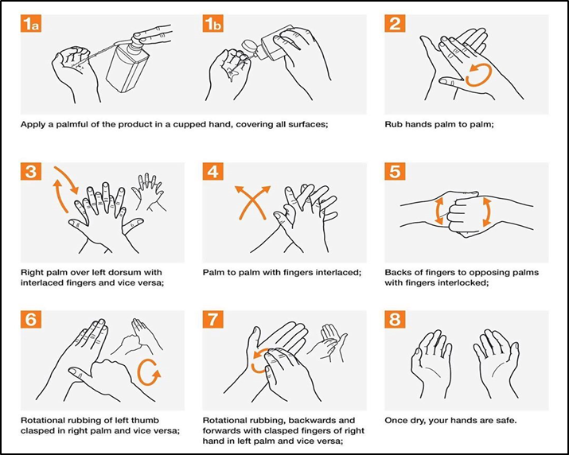

Annex 3 – Protocol for making bleach solution and disinfecting surfaces, commodities and tools

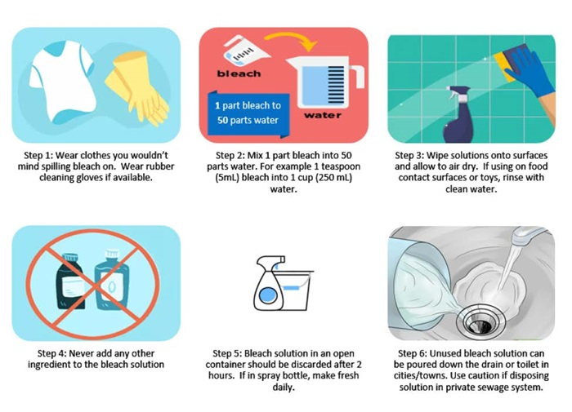

- Use fresh bleach solution each day.
- Put on a new pair of gloves.
- Spray disinfecting solution on the following items and wipe with clean paper towel.
  - Laminated job aid
  - SPAQ drug packets
  - Pen
  - Mobile phone
  - Chairs and tables
  - Door handles and faucets
  - Any equipment used for SMC delivery except cloth or fabric
- Remove gloves as per protocol for “Protocol for using disposable gloves”.
- Wash hands as per protocol for “Protocol for hand washing with soap and water”.
- Allow items to dry for 5 minutes before touching with clean hands.

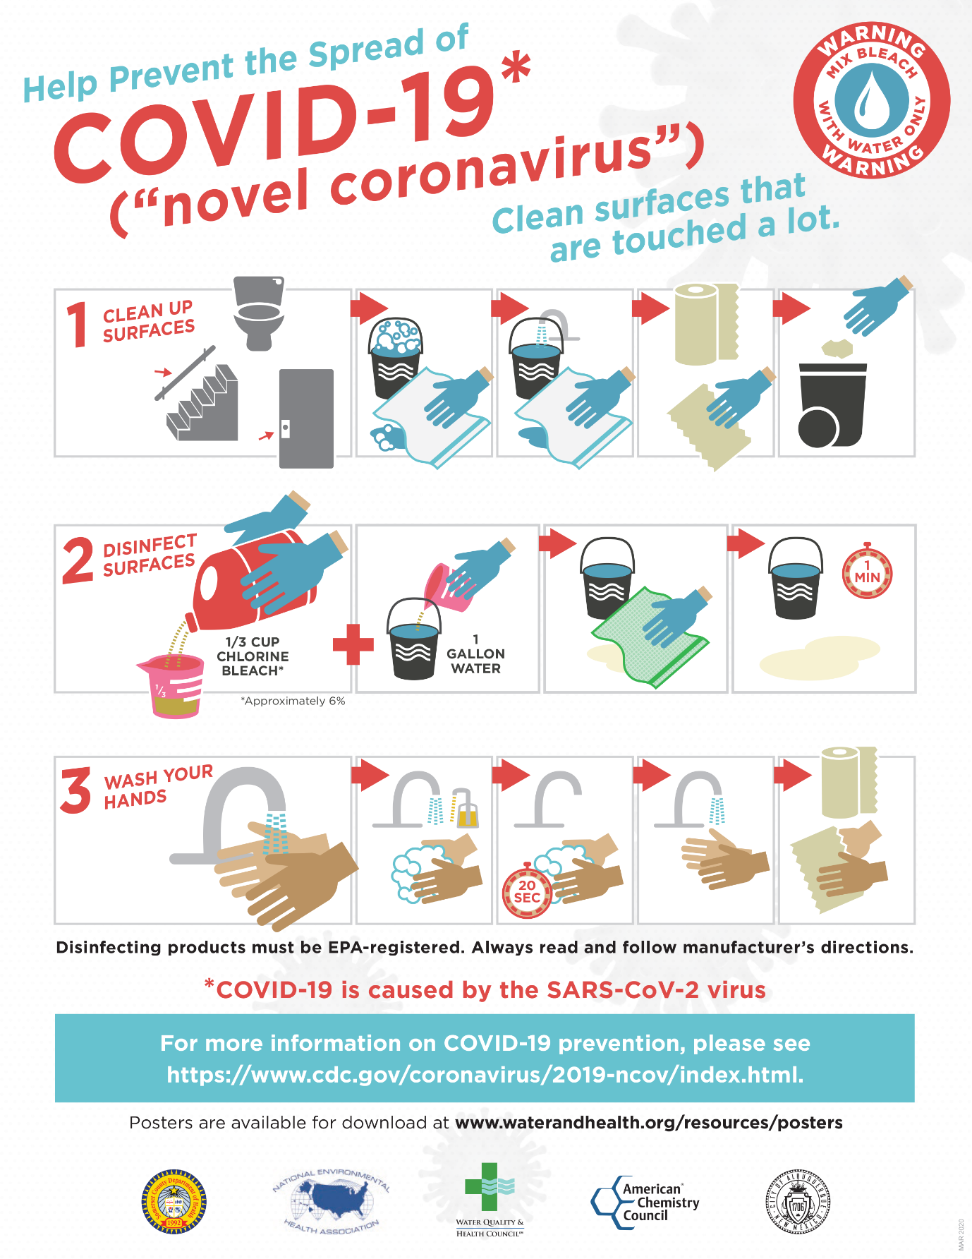

Annex 4 – Protocol for using face masks

Putting on a face mask
- Wash your hands with soap and water for 30 seconds or clean with hand sanitiser before touching the mask.
- Remove a mask from the box and make sure there are no obvious tears or holes in either side of the mask.
- Determine which side of the mask is the top. The side of the mask that has a stiff bendable edge is the top and is meant to mould to the shape of your nose.
- Determine which side of the mask is the front. The coloured side of the mask is usually the front and should face away from you, while the white side touches your face.
- Hold the mask by the ear loops. Place a loop around each ear.
- Mould or pinch the stiff edge to the shape of your nose.
- If using a face mask with ties: Then take the bottom ties, one in each hand, and secure with a bow at the nape of your neck.
- Pull the bottom of the mask so it covers your mouth and your chin.
- Avoid touching the outer surface of the mask while using it, also avoid pulling the mask down and back while in use.

Taking off a face mask
- Wash hands with soap and water for 30 seconds or clean hands with an alcohol-based hand sanitiser before touching the mask.
- Avoid touching the front of the mask. The front of the mask is contaminated. Only touch the ear loops/ties/band.
- After use, take off the mask; remove the elastic loops from behind the ears while keeping the mask away from your face and clothes, to avoid touching potentially contaminated surfaces of the mask.
- Hold both of the ear loops and gently lift and remove the mask.
- Discard the mask in a closed in a sealed plastic bag and dispose of small plastic bag in larger biowaste bag.
- Wash hands with soap and water for 30 seconds or clean hands with an alcohol-based hand sanitiser

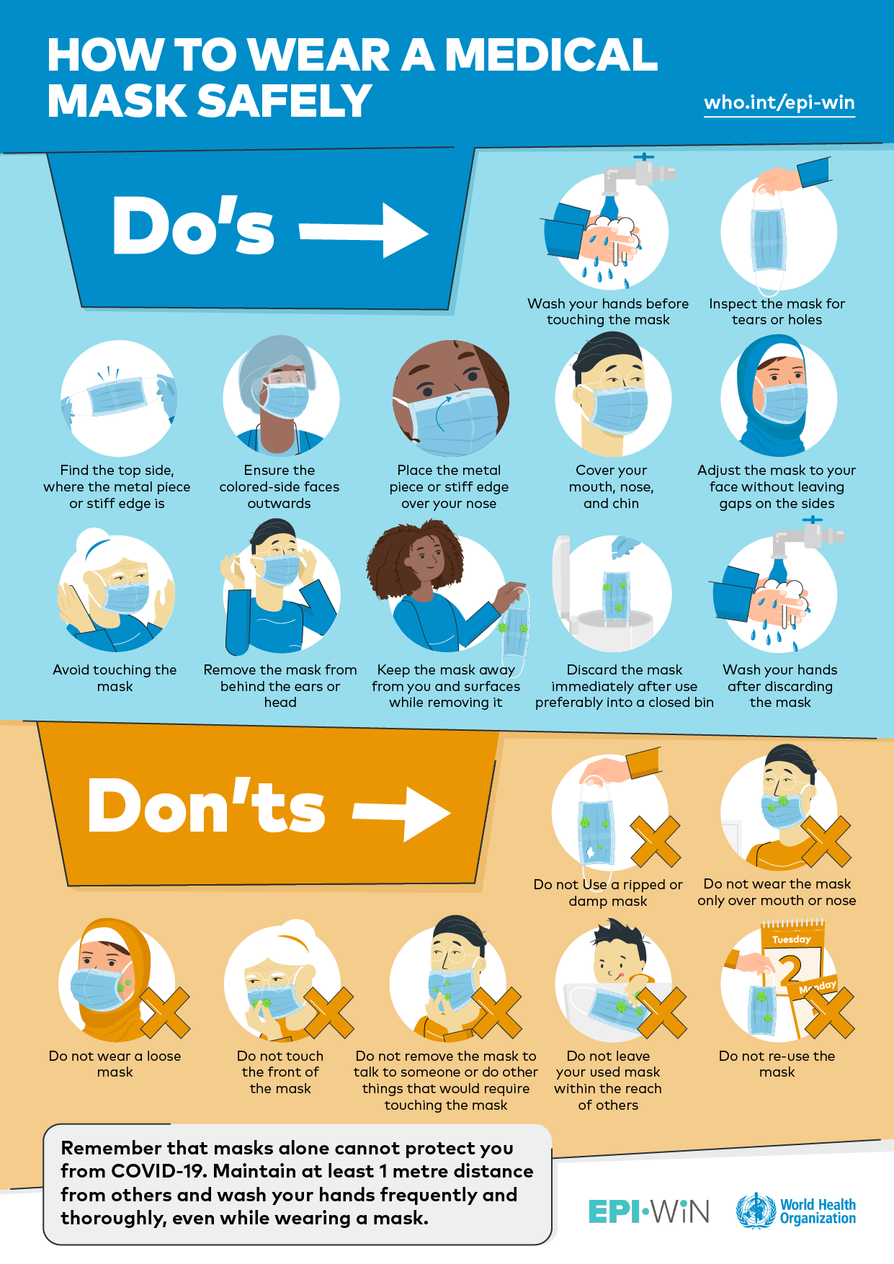

Annex 5 – Protocol for using disposable gloves
- Outside of gloves are contaminated.
- Using a gloved hand, grasp the palm area of the other gloved hand and peel off first glove.
- Hold removed glove in gloved hand.
- Slide fingers of un-gloved hand under remaining glove at wrist and peel off second glove over first glove.
- Discard gloves in small sealable bag and lace small bag in large bio waste bag
- Immediately wash your hands with soap and water for 30 seconds or clean with alcohol-based hand sanitiser.

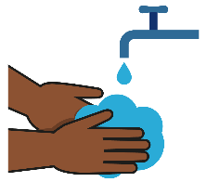
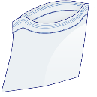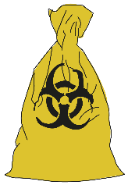

Malaria Consortium. COVID19 Infection Prevention and Control (IPC) Behaviours for MC Related Activities; March 2020.

