FEDERAL MINISTRY OF HEALTH

NATIONAL MALARIA ELIMINATION PROGRAMME
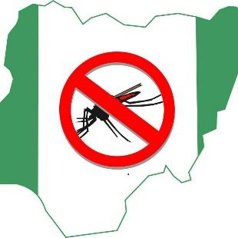

National Protocol for the Conduct of Seasonal Malaria Chemoprevention End-of-Round Coverage Survey NOVEMBER 2020

CONTENTS
CONTENTS 2
ACKNOWLEDGEMENTS 4
ABBREVIATIONS AND ACRONYMS 5
BACKGROUND 6
SURVEY OBJECTIVES 9
Primary objectives 9
Secondary objectives 10
KEY SMC SURVEY INDICATORS 10
METHODS 13
Survey design 13
Survey Area 14
Survey population 14
Inclusion criteria 14
Sample size 14
Sampling frame and sampling design 15
DATA COLLECTION 16
Survey Tools and Pilot 16
Data Collection Procedures 17
Sensitization of Communities Participating in the Household Survey 18
MANAGEMENT OF FIELDWORK 18
DATA MANAGEMENT 18
Data analysis 19
ETHICAL CONSIDERATIONS 19
SAFETY CONSIDERATIONS FOR SURVEYS DURING COVID-19 PANDEMIC 19
SCHEDULE FOR COVERAGE SURVEY 20
Annex 1: Schedule of the 2020 SMC coverage survey in the states 21
Annex 2: Sample SMC Coverage Survey Questionnaire 21
Annex 3: SMC & COVID-19 Operational Guidance 25

ACKNOWLEDGEMENTS
We express our profound gratitude to the Honourable Minister of Health, Dr Osagie Emmanuel Ehanire, for his vision of a malaria free nation and all principal officers in the Federal Ministry of Health and the National Malaria Elimination Programme for championing the malaria-free Nigeria vision. Further commendations to the Commissioners of Health, the Directors of Public Health and the Programme Managers of the implementing states at the time of developing this national protocol (Bauchi, Borno, Jigawa, Kano, Katsina, Kebbi, Sokoto, Yobe, and Zamfara States)
Funding and technical support for the development of this protocol was provided from Malaria Consortium’s philanthropic funding for Seasonal Malaria Chemoprevention (SMC).

List of Contributors
- Dr Nnenna Ogbulafor, Head of Case Management Branch, NMEP
- Dr Perpetua Uhomoibhi, Director/Head Monitoring and Evaluation Branch, NMEP
- Festus Okoh, Deputy Director, Monitoring and Evaluation Branch, NMEP
- Dr Jamilu Ibrahim Nikau, Senior Programme Officer, NMEP-GF-PMU
- Dr Emmanuel Shekarau, Case Management Branch, NMEP
- Dr Aminu Haruna, Monitoring and Evaluation Branch, NMEP
- Olatunde Adesoro, Programme Director (SMC) Malaria Consortium
- Dr Olusola Oresanya, Country Technical Coordinator, Malaria Consortium
- Dr Sol Richardson, Epidemiologist, Malaria Consortium
- Dr Abimbola Phillips, Research Specialist, Malaria Consortium
- Jane Onyilo, Monitoring and Evaluation Manager, Malaria Consortium
- Dr Ibrahim Maikore, World Health Organisation
- Dr Uwem Inyang, Senior Malaria Program Specialist, USAID
- Dr Abimbola Olayemi, Management Sciences for Health
- Dr Chukwuyem Okoh, Malaria Logistics Support Manager, USAID GHSC-PSM
- Dr Frank Oronsaye, Senior MEAL Manager, CRS
- Akinola Shonde, Technical Malaria Specialist, CRS

ABBREVIATIONS AND ACRONYMS

AQ | Amodiaquine
CAPI | Computer-assisted personal interviews
CDD | Community Drug Distributors
CI | Confidence interval
DOT | Directly observed treatment
EA | Enumeration Area
ESS | Effective sample size
GPS | Geographical Positioning System
HF | Health Facility
ICC | Intra-cluster correlation
LGA | Local Government Area
LLIN | Long-lasting insecticide nets
M&E | Monitoring and Evaluation
NHREC | National Health Research Ethics Committee of Nigeria
NMEP | National Malaria Elimination Programme
NMIS | National Malaria Indicator Survey
NPHC | Population and Housing Census of the Federal Republic of Nigeria
NPopC | National Population Commission
RBM | Roll Back Malaria
RDT | Rapid Diagnostic Test
SMC | Seasonal Malaria Chemoprevention
SP | Sulfadoxine-pyrimethamine
WHO | World Health Organization

BACKGROUND
Malaria remains a disease of public health importance globally. In 2018, an estimated 228 million cases of malaria occurred worldwide with Nigeria contributing 25% to the global malaria burden and 24% malaria death. (WHO, 2019). Children under 5 years remain the most vulnerable group affected by malaria. According to the 2019 World Malaria Report (WHO, 2019) children under five years accounted for 67% (272,000) of all malaria deaths worldwide in 2018. As part of other high impact interventions for the control of malaria in Nigeria, the Federal Ministry of Health adopted the World Health Organization (WHO) recommendation for Seasonal Malaria Chemoprevention (WHO, 2012) to prevent malaria in those most vulnerable to the disease’s effects in the Sahel sub-region, where malaria transmission is highly seasonal and most morbidity and mortality occur during the rainy season.
Seasonal Malaria Chemoprevention (SMC) is the administration of four monthly courses of sulfadoxine-pyrimethamine (SP) and amodiaquine (AQ), or SPAQ, to children between 3 and 59 months during the rainy season in the Sahel sub-region where malaria transmission is highly seasonal and the majority of clinical malaria cases (>60%) occur during a short period of 3-4 months (WHO, 2012). The objective of SMC is to maintain therapeutic antimalarial drug concentrations in the blood throughout the period of greatest risk. SMC has been shown to be safe, feasible, effective, and cost-effective for the prevention of malaria among children under five. WHO estimates that SMC can prevent 75% of malaria episodes and severe malaria cases in the target (WHO, 2012).
SMC involves the administration of SPAQ to eligible children in yearly rounds of four monthly courses (cycles) during the peak period of malaria transmission (usually between July to October) with distribution cycles approximately 28 days apart. The medicines are typically administered through door-to-door campaigns by Community Drug Distributors (CDDs) during a period of three to four days per cycle. Each monthly course consists of one dispersible tablet of SP and three daily dispersible tablets of AQ. A dose of SP and the first dose of AQ are administered as directly observed treatment (DOT), that is, by or under the supervision of CDs to ensure that the tablets are correctly dissolved, and that the child fully ingests the drugs without spitting them out or vomiting. Children who vomit or spit out the drugs within 30 minutes are given a second dose under supervision of the CDs. The remaining two doses of AQ are administered by the caregiver – one each over the following two days; that is, the CDs leave a blister with the two remaining tablets with caregivers and provide instructions on how to administer and record the dose on the SMC Child Record Card. If a child vomits or spits out the second or third dose of AQ, caregivers are encouraged to request a replacement dose from the nearest health facility. Lead mothers – who are well known and respected community women – are recruited to visit the households from the second day of distribution and remind the caregivers to give the last two doses as instructed.
Children under 3 months or over 5 years, as well as children who are severely ill, who are taking sulfa-containing medications, and those with known allergies to SP or AQ are excluded from SMC. CDs mark each house they have visited, indicating whether treatment was completed. They are instructed to refer children with fever to the nearest health facility, where they should be tested for malaria using a rapid diagnostic test. If the test result is negative, children are given SP and the first dose of AQ by the health facility worker, giving the remaining two doses of AQ to the caregiver for administration over the following two days.
The SMC programme is integrated with a robust monitoring and evaluation component that includes in-process and end-of-process assessment of key indicators to measure progress and achievements of results. Of note is the end-of-round coverage survey that is conducted to measure the coverage and quality of implementation of the SMC programme at the conclusion of the four cycles.
Nigeria adopted the WHO policy recommendation on SMC in 2014 following the conduct of pilot studies in seven local government areas (LGAs) in three of the States in the Sahel area; Jigawa, Kano, and Katsina States. Thus, in 2015, implementation of SMC took place in 6 LGAs in Jigawa and Katsina, which expanded to 52 LGAs in Sokoto, Zamfara, Jigawa and Borno in 2016. By 2020, the nine Sahel states eligible for SMC intervention (Figure 1) had full implementation of SMC in all their LGAs except for Bauchi State with only 10 SMC-implementing LGAs.
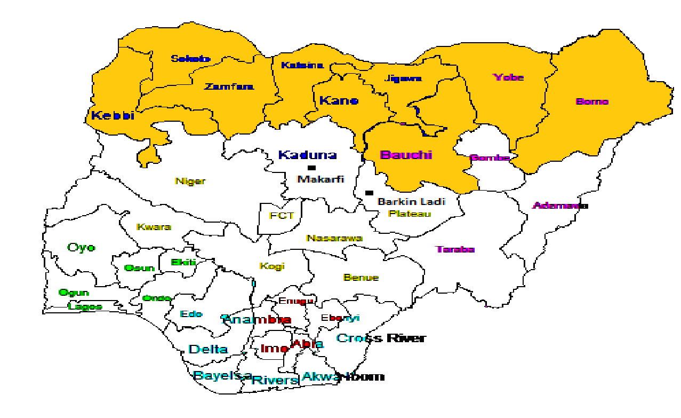
Status in 2020
SMC eligible
Non-SMC

Figure 1: Nine States in the Sahel area of Nigeria eligible for Seasonal Malaria Chemoprevention as at 2020

Currently, over 9 million children aged 3–59 months are eligible for SMC in these states. However, a recent malaria risk stratification mapping that was conducted by the National Malaria Elimination (NMEP) as part of the review of the 2014-2020 National Malaria Strategic Plan (NMSP), identified the need to expand the geographical scope of the SMC implementation scale to include States in the non-Sahel region that are emerging with similar rainfall pattern, thus similar malaria transmission intensity The additional States (Figure 2) have been proposed in the next NMSP 2021–2025 to also implement SMC with the support of the NMEP and its Roll Back Malaria (RBM) partners.

This protocol was developed to provide guidance for the collection of end-of-round coverage data after the implementation of the fourth cycle of SMC which will be used to measure key performance indicators over the entire round for each year of SMC implementation.
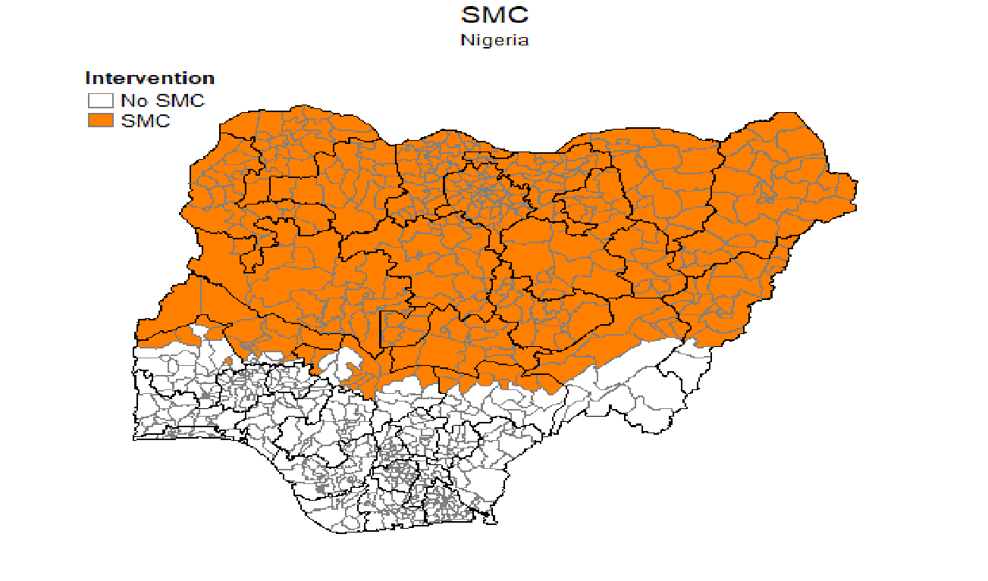
Figure 2: Nine Sahel subregion States plus nine newly-identified States eligible for Seasonal Malaria Chemoprevention in Nigeria

SURVEY OBJECTIVES
The overall goal of the end-of-round coverage survey is to establish the SMC coverage and determine the quality of implementation of the fourth cycle and the overall SMC campaign in the implementing states. The primary and secondary objectives of the survey are listed below.

Primary objectives
The primary objectives of the surveys are to:
- Determine the proportion of self-reported SPAQ administration among the targeted population (children between 3 and 59 months) during cycles 1 to 4
- Ascertain the level of adherence to the SMC protocol by the CDs during of cycles 1 to 4
- Determine the level of adherence to SPAQ administration regimen by caregivers of targeted children on days two and three of the fourth cycle of SMC

Secondary objectives
The secondary objectives are to:
- Identify the most accessed information channel on SMC by caregivers of targeted children
- Assess the adequacy of information given to mothers/ caregivers of targeted children on what to do in the event of an adverse reaction to SMC medicine
- Ascertain the proportion of ineligible children age 5-10 years that were administered SPAQ during the SMC
- Explore the ideational factors such as perceptions and attitudes that are related to SMC such as caregivers believe that SPAQ prevents malaria, and perceived self-efficacy to administer SMC.

KEY SMC SURVEY VARIABLES
The survey questionnaire will provide information on the following key varibles:
- SMC survey coverage: Proportion of eligible children treated with SMC among the total eligible children sampled for the survey
- SMC over age treatment: Proportion of ineligible children age 5-10 years that were administered SPAQ during SMC
- Blister retention: Proportion of households with blister retained among eligible households
- Children treated with SP+AQ on Day 1 of cycle and supervised (DOT): Proportion of treated eligible children for whom delivery was supervised among total treated eligible children
- Card retention: Proportion of households where child card is retained among all eligible households sampled
- Home doses ticked on card (0, 1, 2, and 3, including day 1 dose): Proportion of households where at least one SMC dose is ticked on card among households where card is retained.
- SMC coverage by doses (0, 1, 2, and 3, including day 1 dose): Proportion of eligible children covered by the 3 doses of SP+AQ (by number of doses) among total eligible children sampled
- SMC coverage by cycles (Cycle 1, 2, 3 and 4): Percentage coverage of eligible children who received full course of SMC for at least 3 cycles among eligible children sampled
- Coverage of children aged 5–10 years: Children over 5 years covered among children over 5 years sampled
- SMC refusal rate: Proportion of households refusing SMC among eligible households visited by community distributor
- SMC awareness: Number of caregivers reporting awareness of SMC among eligible households visited by community drug distributor
- Knowledge about SMC purpose: Proportion of caregivers responding correctly to question on purpose of SMC among eligible households visited by community distributor
- Knowledge about number of SMC doses to be given: Proportion of caregivers responding correctly to question on number of recommended SMC doses among eligible households visited by community distributor
- Knowledge about age eligibility for SMC: Proportion of caregivers responding correctly to questions related to age eligibility among eligible households visited by community distributor
- Knowledge about timing of SMC administration: Proportion of caregivers responding correctly to questions related to days SMC doses are given among eligible households visited by community distributor
- Knowledge of SMC adverse event: Proportion of caregivers who know what to do in case of SMC-related adverse event among eligible households visited by community drug distributor
- Awareness of SMC: Proportion of caregivers who heard town announcements about SMC within last month among household with eligible children sampled
- Awareness of SMC: Proportion of caregivers who heard announcements about SMC through mass media within the last month among household with eligible children sampled
- Awareness of SMC: Proportion of caregivers who heard announcements about SMC through town announcers within the last month among household with eligible children sampled
- Awareness of SMC: Proportion of caregivers who heard announcements about SMC through community leaders within the last month among household with eligible children sampled
- Awareness of SMC: Proportion of caregivers who heard announcements about SMC through health worker within the last month among household with eligible children sampled
- Confidence to give second and third SMC doses: Proportion of caregivers reporting self-confidence in giving second and third SMC doses among eligible households visited by community drug distributor
- Confidence to identify adverse events: Proportion of caregivers reporting self-confidence in identifying adverse events among eligible households visited by community drug distributor
- Adverse drug reaction: Percentage of fever reported by caregivers of eligible children with ADR among households visited by CDD
- Adverse drug reaction by type: Percentage of yellow eyes reported by caregivers of eligible children with ADR among households visited by CDD
- Adverse drug reaction by type: Percentage of diarrhea reported by caregivers of eligible children with ADR among households visited by CDD
- Adverse drug reaction by type: Percentage of vomiting reported by caregivers of eligible children with ADR among households visited by CDD
- Adverse drug reaction by type: Percentage of severe skin rash reported by caregivers of eligible children with ADR among households visited by CDD
- Confidence to take child to health centre in the occurrence of adverse events: Proportion of caregivers reporting self-confidence to take child to health centre in case of adverse events among eligible households visited by community drug distributor.
- Perception on SMC: Proportion of caregivers reporting positive perception of SMC among eligible households visited by community drug distributors.
- Use of personal protective equipment by distributors: Proportion of caregivers reporting that distributor wore mask among eligible households visited by community drug distributor
- Delivery of COVID-19 prevention messages: Proportion of caregivers who reported to have received information on COVID-19 prevention during SP+AQ administration among eligible households visited by community drug distributors.
- Household possession of mosquito net: Percentage of household with at least one mosquito net (treated or untreated) among households visited by CDD
- Use of mosquito net by persons in the household: Percentage of persons who slept under an LLIN last night among household visited by CDD
- Adherence to SMC delivery protocol: Percentage of household correctly marked by CDD among households visited by CDD
- Adherence to SMC delivery protocol: Percentage of CDDs known to caregivers among household visited by CDD
- Adherence to SMC delivery protocol: Percentage of HH visited by lead mother to remind caregiver to administer AQ on day2 and 3
- SMC impact assessment: Percentage of Children treated with SMC, who had fever within the last month (caregiver-reported) among households visited by CDD
- SMC impact assessment: Percentage of Children treated with SMC, who had fever was taken to the HF (caregiver-reported) among households visited by CDD
- SMC impact assessment: Percentage of Children treated with SMC, who had fever and tested positive for malaria by RDT/Microscopy (caregiver-reported) among households visited by CDD

Other information to be obtained will include the following:
- Household refused distributor to speak to householder due to COVID-19
- Household member reported COVID-19 symptoms within the last month prior to survey
- Community distributor known to caregiver
- Reason child did not receive SP (Day 1)
- Reason child did not receive AQ on Day 2 and 3
- Reasons for non-availability of SMC card
- Sources of information about SMC
- Measures of socioeconomic position of household (occupation, assets and amenities, level of education of head of household and caregiver)
- Re-dosing on Day 1 in the case of vomiting
- Receipt of SMC outside house-to-house SMC distribution (e.g. opportunistically from health facility personnel, a fixed point
- Questions on recent places of residence and migration

METHODS

Survey design
A cross-sectional survey will be conducted in each of the states implementing SMC to collect data and measure coverage of the SMC treatment programme among eligible children aged 3-59 months in the state.

Survey Area
The survey will be conducted in representative enumeration areas (EAs) across the states where the SMC campaign was conducted by the SMC intervention in Nigeria. Details about the sampling frame and description of the EAs is further described below.

Survey population
The survey population will be primary caregivers and heads of households with children age 3–59 months who were resident in locations of sampled survey clusters during the period of the SMC programme implementation.

Inclusion criteria
All households with children age 3–59 months who were resident in the survey location during the period of the SMC programme implementation will be eligible for selection. The survey will adopt the definition of a household as used in the National Malaria Indicator Survey (NMIS), i.e. a person or a group of persons, related or unrelated, who live together, share common cooking and eating arrangements, and recognize one adult member as the head of household.
Exclusion criteria
Households with caregivers who are too ill to participate in the survey would be excluded.

Sample size
Using the a formula for calculating sample size for a discrete outcome (Lwanga et al, 1991) to estimate an expected coverage of 80% among eligible children with a desired precision of ±5%, and a standard deviate of 1.96 at the 95% confidence level, a minimum effective sample size (ESS) of 245.862 eligible children is obtained per state.
For the survey, the selected enumeration area constitutes a cluster.
To adjust for design effect due to clustering (Kish, 1965), assuming an intra-cluster correlation (ICC) of 0.2 and an average cluster size (n) of 15 eligible children (WHO, 2018):
Design/cluster effect is given as = 1 + (n-1) * ICC
= 1 + (15-1) * 0.2 = 3.8
Multiplying the Design Effect by the ESS:
245.862 *3.8 = 934. 275
To adjust for non-response, assuming a 95% response rate:
934. 275/0.95 = 983.447 = 980 approximately
For ease of sampling, in each state, a total of 990 matched pairs of caregivers and children aged 3-59 months will be selected from 990 households (assuming one eligible pair per household) in 66 clusters. (See details in Table 1).

Sampling frame and sampling design
The sampling frame proposed for the coverage survey is the Population and Housing Census of the Federal Republic of Nigeria (NPHC), which was conducted in 2006 by the National Population Commission (NPopC). Administratively, Nigeria is divided into states. Each state is subdivided into LGAs, and each LGA is divided into wards. In addition to these administrative units, during the 2006 NPHC, each locality was subdivided into convenient areas called census enumeration areas (EAs). These EAs are referred to as clusters for the SMC coverage survey and are defined based on EAs from the 2006 EA census frame. The survey management team will work with the National Population Commission (NPopC) to obtain a list of EAs and estimated number of households in each EA for the respective survey states.
A modified cluster sampling design will be employed to select 990 caregiver-child pairs in each SMC campaign state (Table 1). In 44 LGAs implementing SMC, at the first stage, 66 clusters will be randomly selected in each state by probability proportional-to-cluster size (PPS). The cluster size refers to the total number of households within an EA. Selected clusters which are security compromised will be replaced by randomly selected back-up clusters. Information about security situations in survey areas will be requested from the appropriate authorities prior to selection.. At the second stage, 15 eligible households will be selected from each selected cluster using a simple random sampling method. This stage will be preceded by a household listing of all eligible households, to generate a household sampling frame. A mapping update of the clusters will also be conducted to ensure that new changes to the existing map are reflected since the last population census was held.
There will be two sets of respondents for the survey with different questionnaires: primary caregivers of children under the age of five and heads of households. In the absence of the head of household, the primary caregiver will respond to the head of household’s questions as much as possible. A primary caregiver in this survey refers to any individual, aged 15 years or over, with the primary responsibility for the feeding and daily care of at least one child under the age of five, in a household where he or she has been resident prior to the start of the SMC programme or one month before the last cycle of the treatment. We defined a household head as a member of the family who manages the resources and is the final decision maker in the household.
Table 1: Example of Sampling Scheme for SMC Coverage Survey in Kano State
Sampling stages | Kano
No. of LGAs implementing SMC | 44
Clusters selected (A) | 66
Households selected per cluster (B) | 15
Sample size  (@ 1/household) (A*B) | 990

DATA COLLECTION

Survey Tools
A structured survey questionnaire will be administered to the caregiver and head of household using the handheld electronic data collection devices, via a digital online data collection app. This approach will minimize errors in data collection and entry. It will also help in collecting Geographical Positioning System (GPS) information which will serve as part of the quality assurance and provide spatial data for geo-referencing of findings. The questionnaire is designed to be administered to households as the epidemiological unit. The questionnaire is composed of questions related to the selected household and eligible child’s demographics; quality of SMC administration; fidelity to the SMC protocol by CDs; knowledge, attitude and perceptions related to SMC as well as knowledge of COVID-19 (including prevention) among caregivers; practice of CDs in relation to COVID-19 infection control measures. Another set of questions will be asked from the caregiver of a randomly selected child whose age is between 5 and 10 years to measure the proportion of children within the age range who received SMC.
The questionnaires will be administered to caregivers of eligible children by independent research assistants trained on the use of the tool. The data tools will be pretested and piloted in non- survey clusters within the state. This will be done to determine:
- Reaction of the respondents to the research procedure
- Acceptability of the questions asked
- Willingness of the respondents to answer and participate in the survey
- Validity and reliability of the questionnaire
- Time needed to administer the questionnaire
- The feasibility of the sampling procedure
- Adequacy of data collectors per visit for the assessment
- Knowledge and competencies of data collectors
- Effectiveness of training

Data Collection Procedures
The data collection process and fieldwork will last for a period of about seven days in each state. Two data collectors and one supervisor would constitute a team. The supervisor has the responsibility to ensure that data collected is uploaded to the server daily. Questions will be asked exactly the way they were written in the translated language, and in situations requiring interpretation, enumerators would ensure that the meaning of the questions is not altered. An average of 15 households will be covered per team per day.
On arrival in a selected household, the enumerator will identify the head of the household, explain the purpose of the survey, ascertain the presence of at least one child eligible for SMC, and take permission to continue to the next step. The enumerator will then make a list of all children less than 10 years old in the household, including their ages, gender and day 1 SMC administration in cycle 4. Using this list, an eligible child, and another child older than 59 months (if available) will be randomly selected. The enumerator will proceed to interview the eligible child’s parent or primary caregiver after taking informed consent. After completing this interview, the consenting primary caregiver of the selected child above 59 months will also be interviewed to determine if the ineligible child (aged 5–10 years) was given SMC (Day 1). Finally, the head of household will be interviewed for questions related to the household. A unique cluster and household identifier will be automatically generated by the electronic device used for data collection. Each of the selected children will also be given unique identifiers. The dataset obtained will not contain information from which respondents can be identified (e.g. their name) to ensure confidentiality. Field data collection at the households will be carried out using forms which are electronically configured on the android devices.
Fieldwork for data collection will be followed by daily review meetings among data collectors and supervisors to review completed tools, complete quality checks, validate entries and agree on strategies where necessary to facilitate quality data collection including reconciliation of facility names, community name, and descriptions. Data uploads should be made to a central cloud-based database daily to be reviewed by the central quality assurance team.

MANAGEMENT OF FIELDWORK
There should be detailed preparation for fieldwork which will include recruitment and training of field personnel (data collectors and supervisors), data collection, data management and analysis, autonomy and confidentiality of data collection, and data security. Adequate technical support should be given by the Research Coordinator, M&E team, and Data Analyst. The data collectors will report to the supervisors. All challenges encountered at household, community and LGA levels should be documented as lessons learned to guide future implementation. Prior to the main data collection, a pretest of tools should be conducted after which a briefing session will be held to share experiences, lessons learned from the field and plan for the main data collection.

DATA MANAGEMENT
Data collection will be done by computer-assisted personal interviews (CAPI) through online data collection platforms, using electronic android devices. This allows for in-field data entry and server synchronization. Data collected will be verified for quality assurance purposes by the supervisors in-field and uploaded daily to the online platform. The uploaded files will undergo additional consistency checks, cleaned, and saved as appropriate data files e.g. Stata format data files. Extensive data cleaning will be done at the end of the fieldwork prior to and during analysis.

Data analysis
Data analysis will be carried out using statistical software e.g. Stata, SPSS etc. All indicators of interest will be presented in proportions by state and an average across all the states using probability weights. A confidence interval (CI) of 95% will be estimated for each proportion to provide a range of values around the estimate within which it will be expected to fall in the target population.

ETHICAL CONSIDERATIONS
Ethical approval should be obtained for the survey from the National Health Research Ethics Committee of Nigeria (NHREC) to ensure the survey is in accordance with the ethical research standards applied in the Federal Republic of Nigeria. Informed consent will be sought from all respondents by means of a consent form developed in English and translated into the relevant local languages. Respondents should be informed of the nature of the survey, benefits and risks involved, what will be required of them as survey participants, and given an indication of the time that would be required to complete the survey. All personal or biographic data collected as part of this survey will be electronically stored securely within the implementing partner’s central office, de-identified and only available to authorized individuals for analytical purposes to enhance confidentiality. All survey instruments and protocols need to be approved before the survey.

SAFETY CONSIDERATIONS FOR SURVEYS DURING COVID-19 PANDEMIC
Since the first reported COVID-19 case in Wuhan, China on 31st December 2019, the world has been grappling with both the public health and economic ramifications of the COVID-19 pandemic. In the early days of the pandemic, many research activities were halted from fear of COVID-19 infection propagation. However, as research remains ethically relevant even during public health emergencies, research activities have gradually resumed under specified regulations. Therefore, the coverage survey will be carried out according to the existing National Guidelines on COVID-19 during all stages of research activities—training/workshops, meetings, data collection – including consent taking and interviews. The general guiding principles will be to protect all study participants and survey personnel from infection, including training facilitators, data collectors, and supervisors as well as the community members in survey locations. Measures to be taken during survey activities will include social distancing (limiting physical interactions to two meters apart), appropriate use of face masks, frequent hand hygiene, and disinfection of equipment. An operational guidance for implementing SMC in the COVID-19 context developed by the RBM Partnership is available in Annex 3.

SCHEDULE FOR COVERAGE SURVEY
The SMC coverage survey is programmatically required to be conducted within 2-4 weeks of the conclusion of the fourth cycle of SMC. The interval between the last day of cycle-4 implementation and commencement of the survey should not be longer than 4 weeks in extreme circumstances to avoid recall bias among survey respondents. A tentative schedule for the 2020 end-of-round coverage survey in the nine states that implemented SMC is shown in Annex 1.

REFERENCES
Kish, L. (1965), Survey Sampling, John Wiley & Sons. Cited in: Clark, R.G. and Steel, D.G. (2002), The Effect of using Household as a Sampling Unit. International Statistical Review, 70: 289-314

Lwanga, SK, Lemeshow, S and World Health Organization. (‎1991)‎. Sample Size Determination in Health Studies: A Practical Manual. Geneva: World Health Organization. Available online at https://apps.who.int/iris/handle/10665/40062

Malaria Consortium. (2020). Job aid: STEPS for using infection prevention and control to deliver SMC during COVID-19 pandemic. London: Malaria Consortium; 2020. https://www.malariaconsortium.org/gallery-file/06170924-10-smc_covid19jobaid.pdf. Retrieved 19 November 2020.

Schreiner, M. (2015). Simple Poverty Scorecard® Poverty-Assessment Tool Nigeria. http://www.simplepovertyscorecard.com/NGA_2012_ENG.pdf. Retrieved 19 November 2020.

World Health Organization (2012). WHO Policy Recommendation: Seasonal Malaria Chemoprevention (SMC) for Plasmodium falciparum malaria control in highly seasonal transmission areas of the Sahel sub-region in Africa. Geneva: Global Malaria Programme, World Health Organization.

World Health Organization (2018). World Health Organization vaccination coverage cluster surveys: reference manual. World Health Organization.

World Health Organization (2019). World Malaria Report 2019. Geneva: Global Malaria Programme, World Health Organization.

Annex 1: Schedule of the 2020 SMC coverage survey in the states
State | Cycle-4 implementation date | Tentative timeline for coverage survey
Bauchi | 10-13 October | 1st week in November
Borno | End of October* | Last week in November
Jigawa | 7-10 November* | Last week in November
Kano | 5-8 October | 1st week in November
Katsina | 7-10 October | 1st week in November
Kebbi | 7-10 November* | Last week in November
Sokoto | 10-13October | 1st week in November
Yobe | 9-12 October | 1st week in November
Zamfara | End of October* | Last week in November
*Tentative dates depending on confirmation by the states or availability of SMC commodities.

Annex 2 : 2020 SMC Coverage Survey Questionnaire

Annex 3: SMC & COVID-19 Operational Guidance
Comments to note
The protocol requires minor edits as listed below to be noted. MC will work with the selected vendor to firm up the list of indicators and approach to data analysis."
List of observations:
- SMC distribution in 2021 will be implemented over 5 cycles in some states such as Nasarawa, Kogi, and Plateau (according to the malaria risk stratification and rainfall patterns). The document currently has specifications only for 4 cycles.
- A number of variables/indicators have to be redefined to ensure the intended measurements are correctly captured.
- Clarifications/modification needed for the right denominators to be used for several variables e.g., card retention, other variables sub-set by households visited by CDDs (instead of the entire sampled eligible children)
- Some variables which should be measured are overtly missing e.g., overall ADR rate (protocol only specifies by type).
- Schedule of coverage survey implementation needs to be updated for clarity or made generic for yearly use and to include additional new states.

